


STUDENT ID | FULL NAME
22098316 | Lorretta Opoku Nsiah
22412662 | Van-Kpikpi, Vanessa Selasi
22056801 | Michael Gorswin Achel
22128981 | Gideon Elorm Glago
22233989 | Kwabena Awuah Bosompem
22069268 | Asantewaa Isabella
22299460 | Asare Bismark
22309657 | Duah, Ebenezer Ohene Amoako
22304655 | Asante, Stephanhy
22396017 | Amenumey, Jude Kwame Enam
22406063 | Arhinful, Solomon Kwesi
22375144 | Kumah, Michael Nhyira
22382281 | Quayson, Isaac Awortwe
22388561 | Akyea, Benjamin Obeng

Executive Summary & Local Context

The Legon Campus Smart Service Operations Optimizer is an integrated operational platform tailored for the
University of Ghana, Legon campus. Campus service teams — the Physical Development and Municipal Services Directorate (PDMSD), the University of Ghana Computing Systems (UGCS), maintenance teams, security patrols, and campus shuttle logistics — routinely face complex coordination problems. Service requests arrive from academic departments, lecture halls, science laboratories, student hostels, and municipal junctions with varied urgency and strict deadlines.
This system replaces ad-hoc operations with algorithmic decision-making, through five core capabilities:
- Dynamic Service Dispatching — prioritizing urgent repairs and tasks using custom FIFO queues, circular buffers, deques, and min-heaps.
- Optimal Campus Routing — evaluating the quickest paths across 58 campus locations and 117 interconnected road segments using Dijkstra's algorithm, with travel-time and road-condition penalties.
- Network Infrastructure Optimization — generating campus-wide minimum-cost distribution and communication backbones using Kruskal's and Prim's Minimum Spanning Tree algorithms, backed by custom Disjoint Sets with path compression.
- Constrained Resource Allocation — maximizing resolved emergency request values under shift-hour and crew-capacity constraints, via 0/1 Knapsack Dynamic Programming.
- Zero Java-Collection Core — all 13 fundamental linear, tree, priority, and graph data structures were implemented from first principles in Java 21, coupled with SQLite persistent storage and an empirical efficiency benchmarking lab.

Problem Statement, Assumptions & Input–Output Specifications

Core Operational Questions
- Q1 (Priority & Scheduling): Given an arriving stream of campus maintenance requests, which job must be dispatched next to minimize penalty fines and prioritize critical laboratory emergencies?
- Q2 (Shortest Path Routing): What is the fastest traversal route from the Central Administration / Great Hall to distant residential zones (e.g., Jean Nelson, Pentagon, or UGMC), factoring in road condition weights?
- Q3 (Zone Reachability): Which campus facilities are reachable within k road hops from a municipal dispatch center during road blockages or maintenance?
- Q4 (Budget/Capacity Optimization): Given a 240-minute maintenance crew shift and 157 pending requests, what exact subset of jobs maximizes total avoided penalty fines?
- Q5 (Empirical Scalability): How do custom data structure operations scale from N = 100 to N = 10,000+ items compared to theoretical asymptotic bounds?

System Boundaries & Assumptions
- Node Network: The Legon road network is represented as an undirected weighted graph G = (V, E) with |V| = 58 named campus locations and |E| = 117 validated road segments.
- Road Weights: Every road has a base travel time in minutes and a road condition weight factor w, ranging from 1.0 to 1.8. The total edge weight is computed as:
Cost = travelTime_min × roadConditionWeight
All weights are strictly positive (greater than 0), which satisfies the precondition required for Dijkstra's algorithm to work correctly.
- Crew Shift Horizon: Maintenance shifts are modeled at standard 4-hour (240-minute) intervals, with a 15minute fixed service overhead per job.
- Persistence Boundary: CSV seed files initialize the SQLite relational database (legon_hub.db), and all subsequent state changes, runs, and audit undo logs are read from and written to SQLite tables.

Formal Input–Output Problem Specifications (5 Core Operations)
Each core operation below is defined by its inputs, its preconditions (what must be true before it runs), its outputs, and its postconditions (what is guaranteed to be true after it runs).
Operation 1 — ShortestPathDijkstra(G, sourceId, targetId)
Inputs
- G: custom Graph (adjacency list, V = 58, E = 117)
- sourceId: integer in [1, 58] (e.g., 1 for Great Hall)
- targetId: integer in [1, 58] (e.g., 58 for Engineering Annex)
Preconditions
- sourceId and targetId exist in G.locations
- all edge weights are greater than 0
Outputs
- path: dynamic array of location IDs representing the sequential route
- totalCost: floating-point value representing total time in minutes
- distanceTable: array of settled shortest costs from source to all V
Postconditions
- totalCost equals the minimum, over all valid paths, of the sum of edge weights along that path ● G remains unmodified
Algorithm: ShortestPathDijkstra(G, sourceId, targetId)
-------------------------------------------------------------------------------1. Initialize dist[1..V] = +INFINITY, prev[1..V] = NULL, visited[1..V] = FALSE
- dist[sourceId] = 0.0
- frontier = new MinHeap()
- frontier.insert(new Node(sourceId, 0.0))
- WHILE NOT frontier.isEmpty() DO:
- curr = frontier.extractMin()
- u = curr.locationId
- IF visited[u] == TRUE THEN CONTINUE
- visited[u] = TRUE
- IF u == targetId THEN BREAK // Early exit optimization
- FOR EACH edge (u, v, weight) in G.adjList[u] DO:
- IF NOT visited[v] AND (dist[u] + weight < dist[v]) THEN:
- dist[v] = dist[u] + weight
- prev[v] = u
- frontier.insert(new Node(v, dist[v]))
- path = new DynamicArray()
- currNode = targetId
- WHILE currNode != NULL DO:
- path.addFirst(currNode)
- currNode = prev[currNode]
- RETURN (path, dist[targetId])

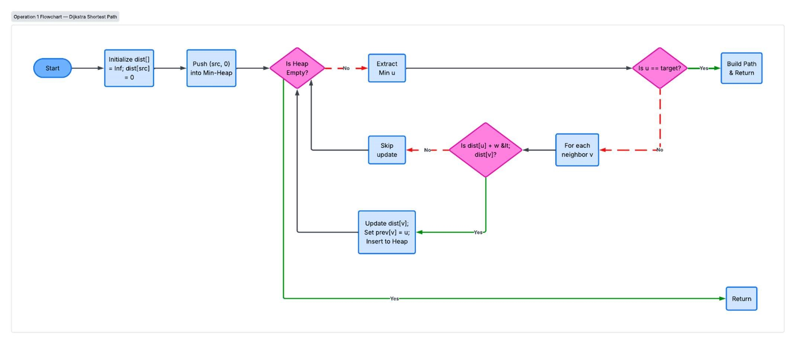
Operation 2 — ScheduleUrgentDispatch(requestStream, mode)
Inputs
- requestStream: custom dynamic array of ServiceRequest objects
- mode: one of FIFO, URGENCY_PRIORITY, DEADLINE_EARLIEST
Preconditions
- requestStream is non-null
Outputs
- dispatchedRequest: the ServiceRequest with the highest priority under the active policy
Postconditions
- under URGENCY_PRIORITY mode, the extracted item has the minimum score in the Min-Heap ● queue/heap size decreases by 1, and an AuditEvent is logged
Algorithm: ScheduleUrgentDispatch(requestStream, mode)
-------------------------------------------------------------------------------1. IF mode == FIFO THEN:
  - IF fifoQueue.isEmpty() THEN RETURN NULL
  - dispatchedRequest = fifoQueue.dequeue()
  - ELSE IF mode == URGENCY_PRIORITY THEN:
  - IF priorityHeap.isEmpty() THEN RETURN NULL
  - dispatchedRequest = priorityHeap.extractMin() // Min-Heap sorted by urgency score
  - ELSE IF mode == DEADLINE_EARLIEST THEN:
  - IF deadlineDeque.isEmpty() THEN RETURN NULL
  - dispatchedRequest = deadlineDeque.removeFront()
  - dispatchedRequest.status = "DISPATCHED"
  - auditLogger.logEvent("DISPATCH", "Dispatched Request ID: " + dispatchedRequest.id) 12. RETURN dispatchedRequest

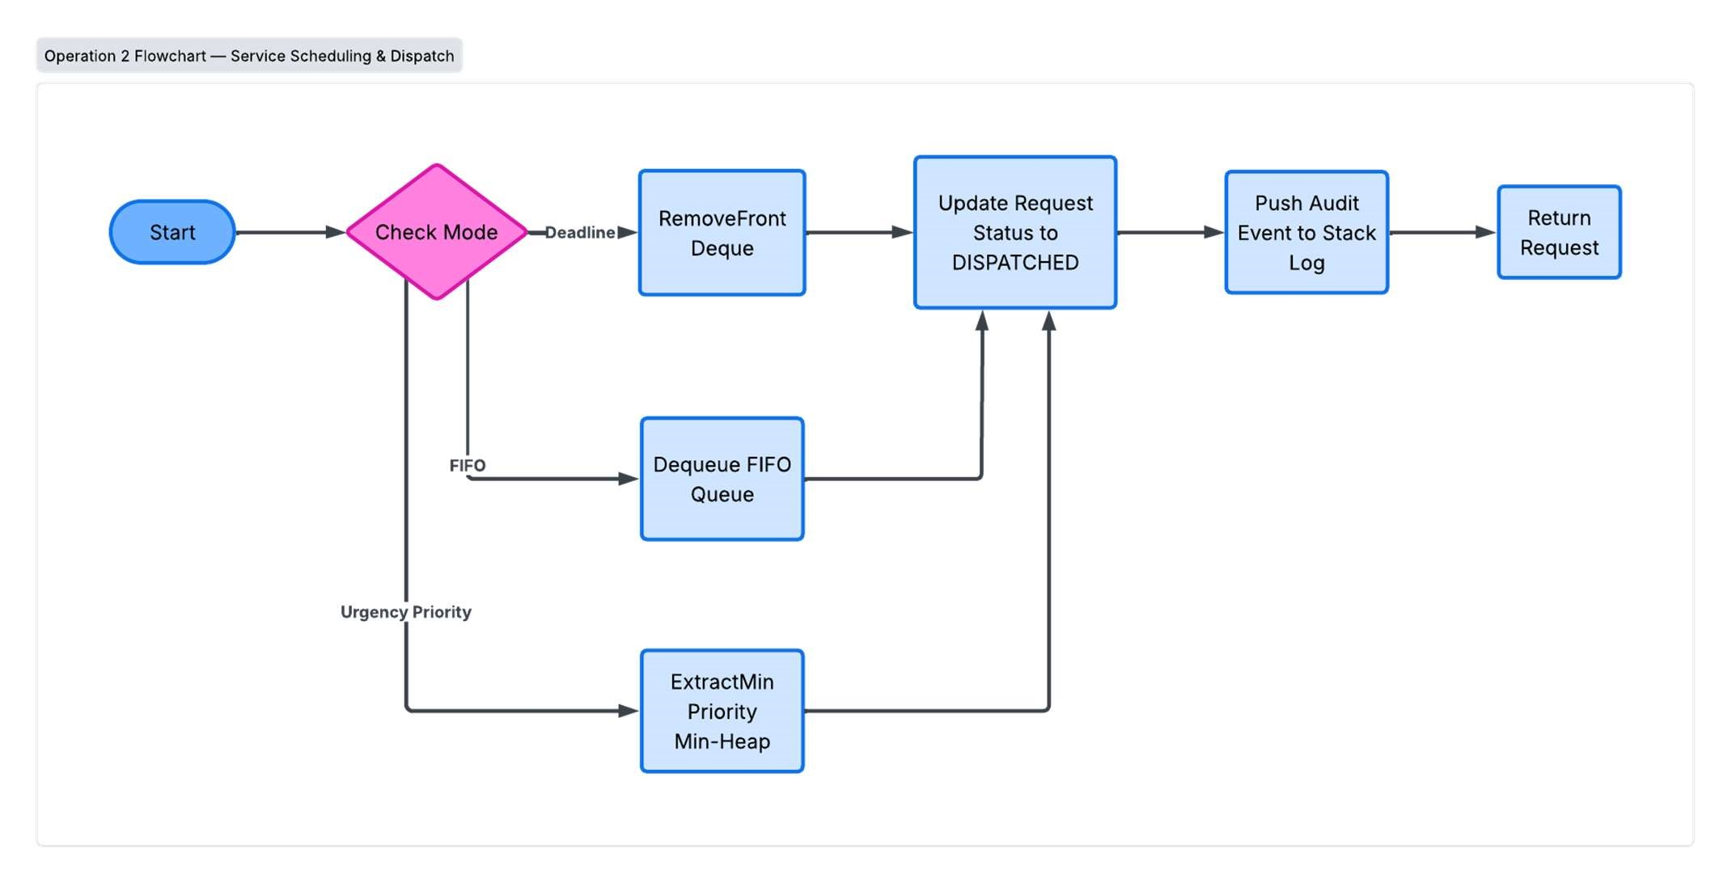
Operation 3 — MinimumSpanningNetwork(G, algorithmChoice)
Inputs
- G: custom Graph
- algorithmChoice: KRUSKAL or PRIM
Preconditions
- G is a connected, undirected graph with V vertices and E edges
Outputs
- mstEdges: dynamic array of Road objects, containing exactly (V − 1) edges
- totalWeight: sum of weights of all selected MST roads
Postconditions
- the graph formed by mstEdges is acyclic and connects all V vertices
- totalWeight is minimal across all possible spanning subgraphs
Algorithm: MinimumSpanningNetwork_Kruskal(G)
--------------------------------------------------------------------------------
- mstEdges = new DynamicArray()
- totalCost = 0.0
- allEdges = G.getAllEdges() // Array of 117 road edges
- MergeSort(allEdges) // Sort edges in ascending weight order O(E log E) 5. dset = new DisjointSet(G.numVertices) // Initialize 58 independent sets
- FOR EACH edge (u, v, weight) IN allEdges DO:
- rootU = dset.find(u) // Find with Path Compression
- rootV = dset.find(v) 9. IF rootU != rootV THEN:
- dset.union(rootU, rootV) // Union by Rank
- mstEdges.add(edge)
- totalCost = totalCost + weight
- IF mstEdges.size() == (G.numVertices - 1) THEN BREAK
- RETURN (mstEdges, totalCost)

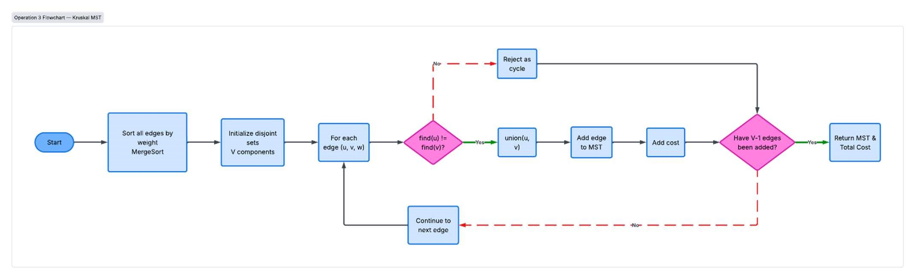
Operation 4 — KnapsackResourceOptimizer(requests, shiftDurationMin, depotId) Inputs
- requests: array of N pending requests (N ≥ 1)
- shiftDurationMin: integer capacity W (e.g., 240 minutes)
- depotId: source dispatch location ID
Preconditions
- all request weights (travel time + service time) are greater than 0; fine values are ≥ 0
Outputs
- selectedJobs: dynamic array of chosen ServiceRequest objects
- totalValueEarned: sum of avoided fines and urgency bonuses
- totalTimeUsed: total duration ≤ shiftDurationMin
Postconditions
- the sum of selected job weights is ≤ W
- totalValue is mathematically optimal (guaranteed by the 0/1 Knapsack formulation)
Algorithm: KnapsackResourceOptimizer(requests, W)
--------------------------------------------------------------------------------
- N = requests.length
- Initialize 2D array K[0..N][0..W] with 0
- FOR i = 1 TO N DO:
- wt = requests[i].travelTime + 15 // Travel time + service overhead
- val = requests[i].fineAmount + requests[i].urgencyBonus
- FOR w = 0 TO W DO:
- IF wt > w THEN:
- K[i][w] = K[i - 1][w]
- ELSE:
- K[i][w] = MAX(K[i - 1][w], K[i - 1][w - wt] + val)
- // Back-tracing to reconstruct optimal solution
- selectedRequests = new DynamicArray()
- currW = W
- FOR i = N DOWNTO 1 DO:
- IF K[i][currW] != K[i - 1][currW] THEN:
- selectedRequests.add(requests[i])
- currW = currW - (requests[i].travelTime + 15)
- RETURN (selectedRequests, K[N][W], W - currW)
--------------------------------------------------------------------------------
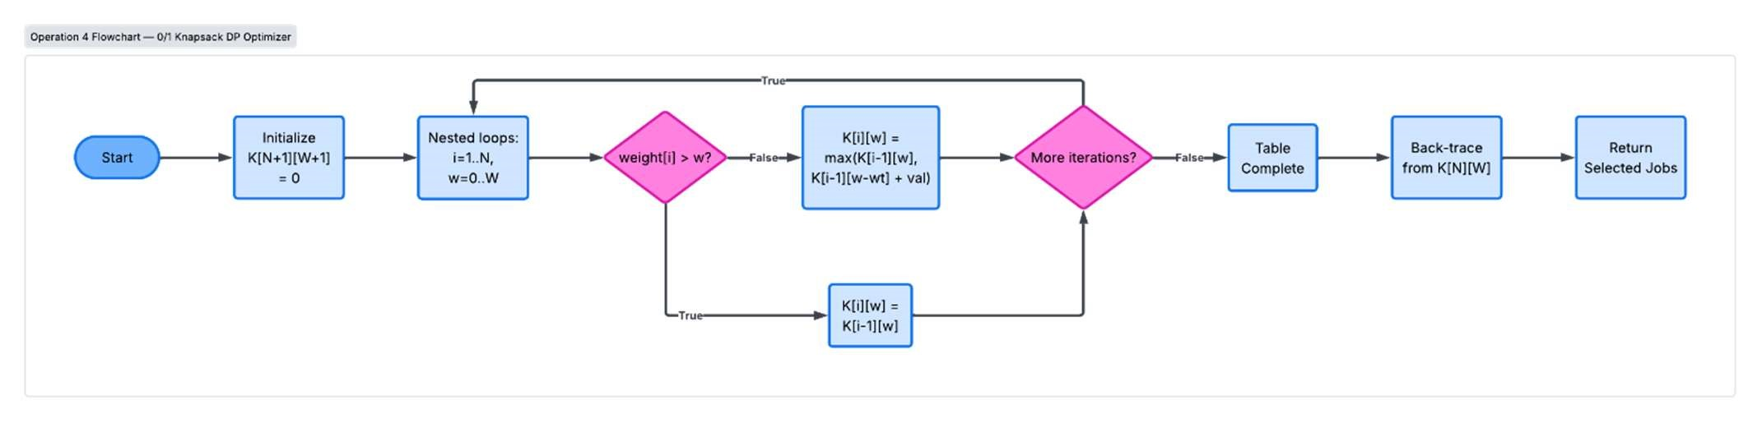

Operation 5 — KeyRangeIndexSearch(BTree, minKey, maxKey)
Inputs
- BTree: custom B-Tree index structure (minimum degree t, derived from the team's index numbers)
- minKey, maxKey: search boundaries (e.g., request IDs or timestamps)
Preconditions
- minKey ≤ maxKey; B-Tree invariants hold
Outputs
- resultSet: dynamic array of matching indexed records
Postconditions
- all returned items satisfy minKey ≤ item.key ≤ maxKey, in sorted order ● node accesses are bounded by O(log_t N + k)

Algorithm: KeyRangeIndexSearch(BTree, minKey, maxKey)
--------------------------------------------------------------------------------
- resultSet = new DynamicArray()
- RangeScan(BTree.root, minKey, maxKey, resultSet) 3. RETURN resultSet
Procedure RangeScan(node, minKey, maxKey, resultSet):
- i = 0
- // Skip keys strictly smaller than minKey
- WHILE i < node.numKeys AND node.keys[i] < minKey DO:
- i = i + 1
- // Traverse subtrees and collect matching keys
- WHILE i < node.numKeys AND node.keys[i] <= maxKey DO:
- IF NOT node.isLeaf THEN:
- RangeScan(node.children[i], minKey, maxKey, resultSet)
- resultSet.add(node.records[i])
- i = i + 1
- // Explore final right child within range boundary
- IF NOT node.isLeaf AND i <= node.numKeys THEN:
- RangeScan(node.children[i], minKey, maxKey, resultSet)

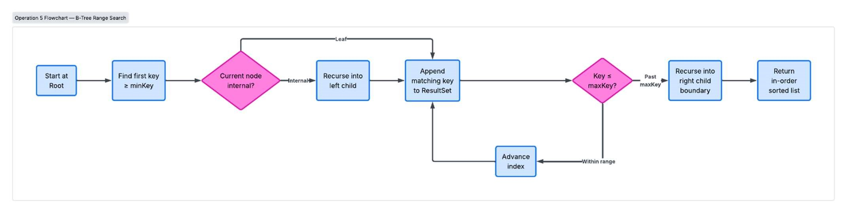

Dataset Description, Data Dictionary & Database Schema

Local Context & Dataset Construction Evidence Note
Our team initially explored modeling the University of Ghana Library System. However, obtaining granular checkout queues, internal shelf indices, and student request logs without exposing private student records or hitting privacy barriers proved unfeasible. In alignment with Section 2 of the course brief, we pivoted to an approved local domain: the University Campus Service Hub.
The dataset was reconstructed around real University of Ghana main campus facilities:
- Academic & Administrative Hubs: Great Hall (1), JQB (2, 3), KAB Lecture Theatre (4), LECIAD (5), Top of Bookshop (8), UGBS (12), Law School (13), UGCS (16), Central Administration Block (39).
- Science & Research Laboratories: Chemistry Department Lab (17), Physics Department Lab (18),
Biochemistry Lab (19), Centre for Ecological Research Lab (20), Computer Engineering Lab (21), Pharmacy Lab (22), Nursing Lab (23), Geology Lab (24), Animal Biology Lab (25), Marine & Fisheries Sciences Lab (26), Plant & Environmental Biology Lab (27), Engineering Annex Workshop (58).
- 14 Student Residential Halls & Hostels: Akuafo Hall (43), Commonwealth Hall (44), Volta Hall (45),
Mensah Sarbah Hall (46), Jubilee Hall (47), Hilla Limann Hall (48), Alex Kwapong Hall (49), Elizabeth Sey Hall (50), Jean Nelson Aka Hall (51), Valco Trust Hostel (52), International Students Hostel (53), Pentagon / AU Hall (54), Bani Hostel (55).
- Transit Hubs, Security & Municipal Services: Legon Second Shuttle Stop (28), Legon Police Station (29), Primary Roundabout Shuttle Stop (30), Okponglo Shuttle Stop (31), Banku Junction (32), Physical
Development and Municipal Services Directorate — PDMSD (33), Bush Canteen (34), University Square
(35), University Avenue Junction (36), Legon Stadium (37), UGMC Hospital (38), Legon Hill Junction (40), Dodowa Road Junction (41), Main Gate Security Post (56), Night Market Junction (57).

Data Quality, Synthetic Coordinates & Duplicate Scrubbing
- Geographic Coordinates: True GPS anchor coordinates were obtained for major landmarks (e.g., Akuafo Hall at 5.64944, -0.18556 and Commonwealth Hall at 5.65060, -0.19000). For unmapped interior departmental wings, synthetic coordinates were calculated within the physical bounding box of the Legon campus (latitude 5.6400° N to 5.6600° N, longitude -0.1950° W to -0.1800° W). These are transparently presented as calibrated spatial coordinates rather than fake GPS sensor readings.
- Duplicate Road Resolution: An early draft of roads.csv contained 19 duplicate road pairs, of which 17 had conflicting weights (e.g., 40 <-> 42 listed as 2.0 min in one entry and 8.0 min in another). The Database pod resolved this by enforcing consistent bidirectional entries. Additionally, Graph.addRoad() includes an automated guard that collapses duplicate road pairs at load time and logs any discrepancies, to prevent non-deterministic routing.
- Automated Loader via DataGenerator.java: Standard CSV imports failed when records had embedded commas in descriptions (such as "Jones Quartey Building (JQB) - First Floor (Rooms 18,19,22,23)"). DataGenerator.java was written to parse, validate, and seed legon_hub.db programmatically, making the entire database build 100% reproducible for all team members. 3.3 Data Dictionary
Table | Attribute | Type | Constraint | Description
locations | locationId | INTEGER | PRIMARY KEY | Unique identifier for campus node (1– 58)
 | name | TEXT | NOT NULL | Official building/venue name

Table | Attribute | Type | Constraint | Description
 | area | TEXT | NOT NULL | Campus sector (Central, Science, Hostels, etc.)
 | type | TEXT | NOT NULL | Type (LectureHall, Laboratory, Hostel, Transit, Security)
 | coordinates | TEXT | NOT NULL | Local coordinate pair (X, Y)
roads | fromLocationId | INTEGER | FK →  locations | Starting location node ID

 | toLocationId | INTEGER | FK →  locations | Destination location node ID
 | distance_m | REAL | NOT NULL | Measured distance in meters
 | travelTime_min | REAL | NOT NULL | Base travel time in minutes
 | roadConditionWeight | REAL | NOT NULL | Condition multiplier (1.0 = Paved, 1.5  = Rough)
service_requests | requestId | INTEGER | PRIMARY KEY | Unique maintenance ticket ID (1– 300+)
 | sourceLocationId | INTEGER | FK →  locations | Incident source origin
 | destinationLocationId | INTEGER | FK →  locations | Target department / dispatch zone
 | category | TEXT | NOT NULL | Electrical, Plumbing, Network, LabEquipment, Security
 | urgency | TEXT | NOT NULL | Low, Medium, High, Critical
 | timeSubmitted | TEXT | NOT NULL | ISO-8601 timestamp
 | deadline | TEXT | NOT NULL | Scheduler SLA deadline
 | status | TEXT | NOT NULL | Pending, In-Progress, Dispatched, Resolved
 | fineAmountGHS | REAL | NOT NULL | Hourly penalty cost in Ghanaian Cedis  (GHS)
resources | resourceId | INTEGER | PRIMARY KEY | Maintenance van, technician crew, or shuttle ID
 | type | TEXT | NOT NULL | ElectricianCrew, PlumbingVan, ITResponseVan
 | name | TEXT | NOT NULL | Assigned unit designation
 | homeLocationId | INTEGER | FK →  locations | Base depot location ID
 | capacity | INTEGER | NOT NULL | Concurrently serviceable request capacity
 | availabilityStatus | TEXT | NOT NULL | Available, OnDuty, Maintenance
algorithm_runs | runId | INTEGER | PRIMARY KEY | Auto-increment benchmark run identifier
 | algorithmName | TEXT | NOT NULL | Name of benchmarked algorithm
 | inputSize | INTEGER | NOT NULL | Evaluated dataset size (N)
Table | Attribute | Type | Constraint | Description
 | timeNs | INTEGER | NOT NULL | Execution time in nanoseconds
 | memoryKb | INTEGER | NOT NULL | Heap memory allocated in kilobytes
 | dateRun | TEXT | NOT NULL | Date and time of experimental trial
audit_events | eventId | INTEGER | PRIMARY KEY | Unique audit record ID
 | eventType | TEXT | NOT NULL | DISPATCH, UNDO, REINDEX, ROUTE_CALC
 | description | TEXT | NOT NULL | Detail log of action performed
 | timestamp | TEXT | NOT NULL | ISO-8601 creation timestamp
Entity Relationship (ER) Schema Diagram
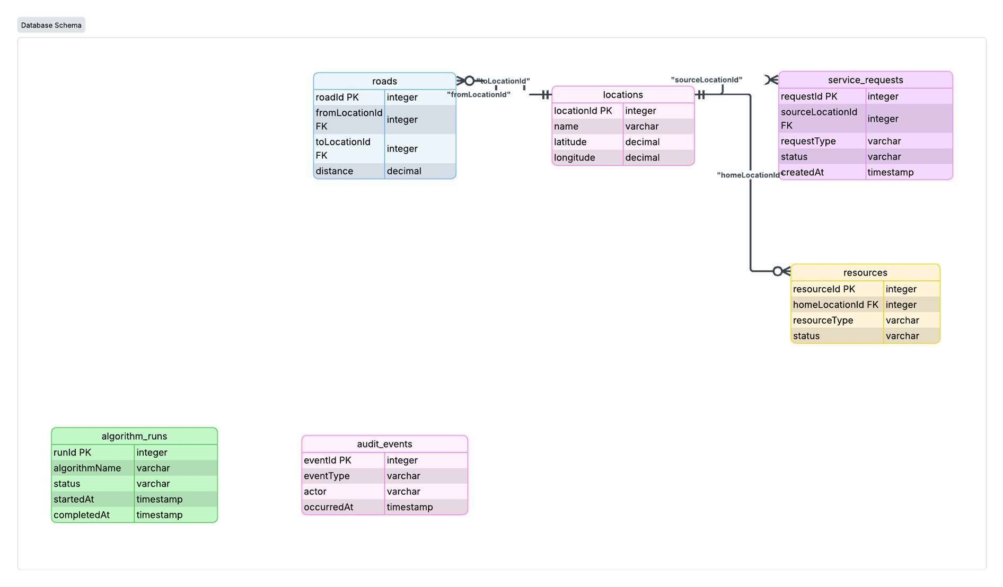

System Architecture & Module Design

The system is structured in strict modular layers:
- Module M1 (Input–Output Specification): mathematical definitions of operational problems, boundary conditions, and flowcharts.
- Module M2 (Database & Data Ingestion): SQLite JDBC driver layer with a repository pattern
(LocationRepository, RoadRepository, RequestRepository, ResourceRepository, AlgorithmRunRepository, AuditEventRepository).
- Module M3 (Custom Data Structure Library): 13 standalone, custom-built data structures implemented without java.util collections.
- Module M4 (Searching & Sorting Engine): linear/binary search and 4 comparison sorting algorithms.
- Module M5 (Service Scheduling Engine): dispatching pipelines operating over FIFO Queue, Circular Queue, Deque, and Priority Queue.
- Module M6 (Indexing Engine): multi-index fast lookup structures using Binary Search Tree, Red-Black Tree, B-Tree, and Hash Table.
- Module M7 (Graph Route Engine): campus topology network modeling, Dijkstra shortest paths, BFS/DFS reachability, Prim/Kruskal MST.
- Module M8 (Optimization Engine): Knapsack 0/1 Dynamic Programming and Greedy Assignment heuristics.
- Module M9 (Testing & Correctness Verification): 192 JUnit tests, trace tables, proof sketches, and loop invariants.
- Module M10 (Empirical Efficiency Lab): scaled benchmarking harness generating multi-trial averages across varying N, exported to CSV and plotted.

High-Level System Architecture Diagram
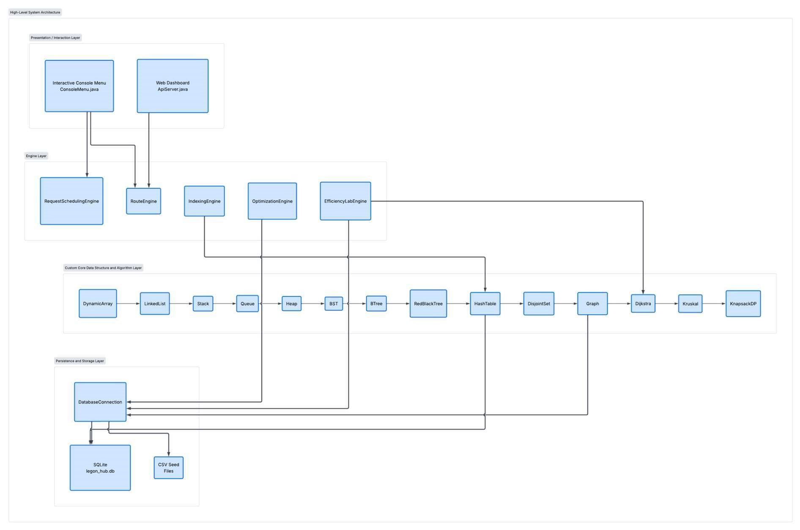

Custom Data Structure Implementation Section

All data structures were implemented in com.campushub.structures.* without built-in Java collections.

Linear Data Structures
- DynamicArray<T>: resizable array backed by a generic Object[]. Doubles capacity when full (2×) and resizes down (0.5×) when load drops below 25%. Provides O(1) amortized insertion, O(1) random access, and O(N) arbitrary element deletion.
- LinkedList<T>: doubly linked list with explicit head, tail, and size pointers, supporting bidirectional addFirst, addLast, removeFirst, removeLast, and an iterable CustomIterator interface for safe traversals without index lookups.
- Stack<T>: array-backed LIFO container supporting push, pop, peek, and isEmpty. Powers the system-wide undo mechanism and the DFS traversal stack.
- Queue<T> & CircularQueue<T>: fixed/resizable ring buffer maintaining front and rear pointers with modulo arithmetic (rear + 1) % capacity. Completely eliminates element-shifting overhead during dequeues, running in strict O(1) time.
- Deque<T>: double-ended queue supporting O(1) insertion and extraction at both ends (addFront, addRear, removeFront, removeRear), used for prioritizing VIP laboratory emergencies.

Priority Structures & Hash Tables
- Heap<T> / PriorityQueue<T>: binary min-heap backed by DynamicArray. Implements siftUp() and siftDown() maintaining the heap-order property — parent index P = (i − 1)/2, left child 2i + 1, right child 2i + 2. Provides O(log N) insertions and extracts.
- HashTable<K, V>: key-value hash map using separate chaining via custom linked buckets. Tracks entry count and capacity, dynamically rehashing and doubling bucket count when load factor α = N / M exceeds 0.75.
- CustomSet<T> & CustomMap<K, V>: mathematical set and associative dictionary abstractions layered directly over the custom HashTable.

Hierarchical & Search Tree Structures
- BST<K, V>: binary search tree with left-smaller / right-larger ordering. Supports recursive/iterative insert, search, and in-order traversal returning keys in strict ascending sequence.
- RedBlackTree<K, V>: self-balancing binary search tree maintaining five red-black properties (root is black; no two consecutive red nodes; equal black-height along all paths from root to leaves). Implements left-rotate, right-rotate, and recoloring on insertion, guaranteeing O(log N) worst-case search height.
- BTree<K, V>: multi-way balanced search tree designed for block-storage indexing, parameterized by minimum degree t ≥ 2. Every non-root node contains between t − 1 and 2t − 1 keys and at most 2t children. All leaves reside at the exact same depth. Employs proactive node-splitting on insertion downwards, preventing cascading splits.

Graph & Disjoint Set Structures
- DisjointSet (Union-Find): disjoint-set forest tracking partition components. Employs union-by-rank (attaching shallower trees under deeper roots) and path compression during find(), yielding an amortized time complexity of O(α(V)) per operation (the inverse Ackermann function).
- Graph: campus network representation providing dual access:

- Adjacency List: a HashTable<Integer, DynamicArray<Road>> mapping each vertex to its outgoing road edges, for efficient neighborhood traversal in O(deg(V)).
- Adjacency Matrix: a 2D matrix array double[][] supporting instantaneous O(1) edge-existence checks.

Data Structure Architectural Diagrams
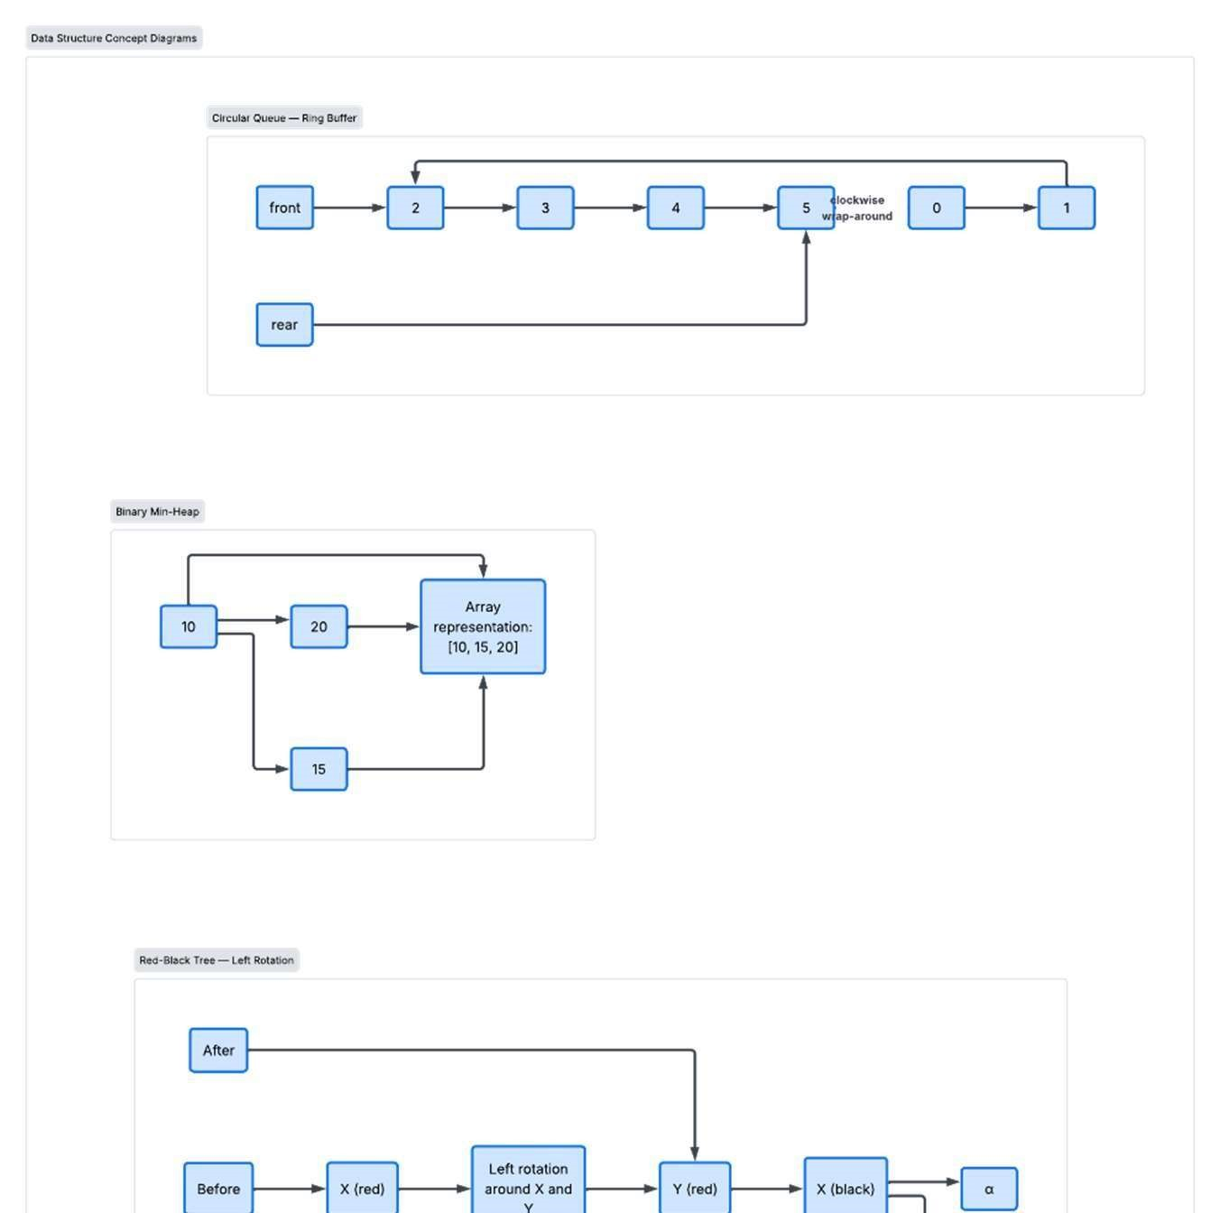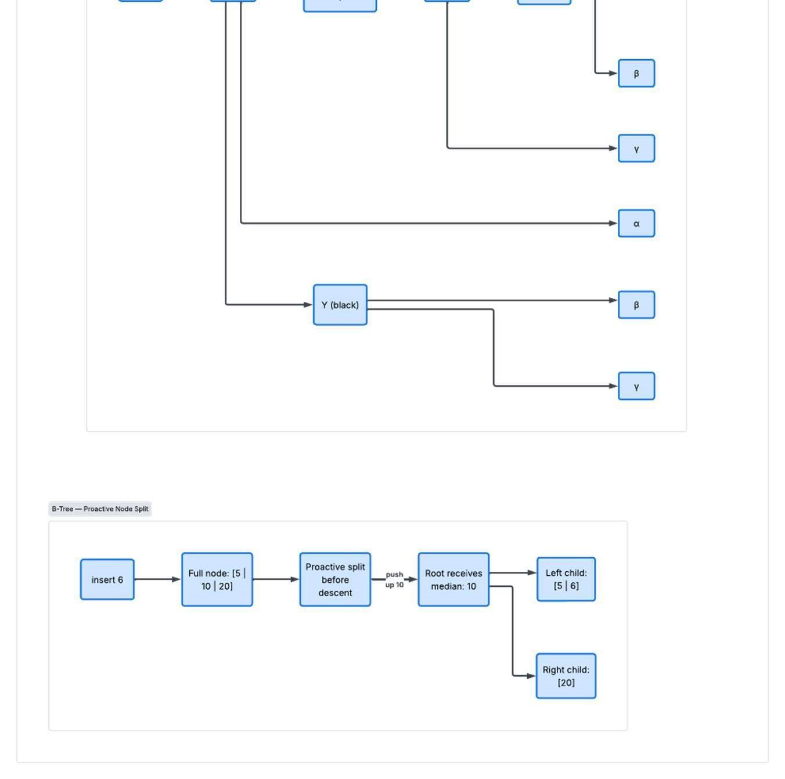

Algorithm Implementation Section

Searching & Sorting Algorithms
- Linear Search: O(N): sequential iteration over unordered arrays. Acts as the baseline for comparison against every other search method.
- Binary Search: O(log N): divide and conquer search over a sorted array, halving the search space each iteration using mid = low + (high − low) / 2.
- Selection Sort: O(N²) time, O(1) space: iteratively scans the unsorted suffix for the minimum element and swaps it into place. In place but unstable.
- Insertion Sort: O(N²) worst and average case, O(N) best case, O(1) space: inserts each element into its sorted position among the elements before it. In place and stable.
- Merge Sort: O(N log N) time, O(N) auxiliary space: divide and conquer algorithm that splits the array in half, recursively sorts each half, and merges the two sorted halves. Stable.
- Quicksort: O(N log N) average, O(N²) worst case, O(log N) stack space: uses Lomuto or Hoare partitioning around a chosen pivot, then recursively sorts the left and right partitions in place. Unstable.

Graph Routing & Traversal Algorithms
- Breadth-First Search (BFS): explores the graph level by level using a FIFO queue. Determines shortest path in unweighted graphs and identifies reachability zones in O(V + E) time.
- Depth-First Search (DFS): explores deeply along branch paths using a LIFO stack / recursion. Detects cycles and connected components in O(V + E) time.
- Dijkstra's Algorithm: computes single-source shortest paths on weighted, non-negative graphs. Uses a min-heap frontier to settle vertices in non-decreasing cost order:
dist[v] = min( dist[v], dist[u] + w(u, v) )
Runs in O((V + E) log V) time.
- Kruskal's Algorithm: computes the Minimum Spanning Tree (MST). Sorts all E edges in ascending weight order and greedily adds edges that connect disjoint components, using DisjointSet. Runs in O(E log E) time.
- Prim's Algorithm: computes the MST by growing a single connected tree from an arbitrary root, using a priority queue of incident cut edges. Runs in O((V + E) log V) time.

Optimization Algorithms
- Greedy Resource Assigner: dispatches requests by sorting strictly by urgency weight or distance. Runs in O(N log N) time. Fast, but can produce suboptimal combinations under fixed resource limits.
- 0/1 Knapsack Dynamic Programming: computes the optimal set of requests S (a subset of {1 … N}) maximizing total value V, subject to total time ≤ W (e.g., W = 240 minutes).
Recurrence relation:
K(i, w) = K(i − 1, w) if wᵢ > w
K(i, w) = max( K(i − 1, w), K(i − 1, w − wᵢ) + vᵢ ) if wᵢ ≤ w
Complexity: O(N · W) pseudo-polynomial time and O(N · W) space, with full back-tracing reconstruction.

Formal Primitive Operation Counts for Efficiency Analysis
To ground theoretical complexity in rigorous operation analysis, as required by Table 6 of the brief, we analyze the exact primitive operations, assignments, comparisons, array accesses, and loop overhead, for two core algorithms.
6.4.1 Insertion Sort Primitive Operation Counting Let the input array have size N.
for (int i = 1; i < N; i++) // c1: loop init, comparison, increment int key = arr[i]; // c2: array access + assignment int j = i - 1; // c3: subtraction +
assignment
while (j >= 0 && arr[j] > key) // c4: comparison + array access arr[j + 1] = arr[j]; // c5: array access + assignment j--; // c6: decrement + assignment arr[j + 1] = key; // c7: array access + assignment

Let t_{i} denote the number of times the while condition is evaluated at step i.
- Best case (already sorted array): t_{i} = 1 for every i in [1, N−1]. The inner loop body never executes. T(N) = c1·N + c2(N−1) + c3(N−1) + c4(N−1) + c7(N−1) = k1·N − k2 = Θ(N)
- Worst case (reverse sorted array): t_{i} = i + 1. The inner loop executes i times at each step, so:
Σ (i = 1 to N−1) t_{i} = Σ (i + 1) = N(N+1)/2 − 1 = (N² + N − 2) / 2 T(N) = ((c4 + c5 + c6) / 2)·N² + lower order terms = Θ(N²)
- Average case (random permutation): on average each element is compared with half of the sorted prefix before it, so t_{i} ≈ i/2 + 1, giving:
T(N) = ((c4 + c5 + c6) / 4)·N² + lower order terms = Θ(N²)
6.4.2 Binary Search Primitive Operation Counting Let N be the size of the search array. At each iteration:
- 1 addition and 1 integer division to compute mid = low + (high − low) / 2
- 2 comparisons: arr[mid] == target, and arr[mid] > target
- 1 assignment updating either low = mid + 1 or high = mid − 1
- Best case: the target is found at the first index examined. Runtime T(N) = c = Θ(1).
- Worst case (unsuccessful search): the search interval is halved repeatedly until it reaches zero length, taking k = ⌊log₂ N⌋ + 1 iterations before terminating. T(N) = c · log₂ N = Θ(log N)
- Average case: T(N) = Θ(log N).

Asymptotic Notation Summary
To characterize the performance limits of every implemented algorithm rigorously, we distinguish between asymptotic upper bounds, Big O, asymptotic lower bounds, Big Omega, and asymptotically tight bounds, Big Theta.
- Big O, f(N) is O(g(N)): the formal worst case upper ceiling.
- Big Omega, f(N) is Ω(g(N)): the formal best case lower floor.
- Big Theta, f(N) is Θ(g(N)): the exact asymptotic growth rate, where the upper and lower bounds coincide.

Algorithm | Best Case (Ω) | Average Case (Θ) | Worst Case (O) | Space | Notes
Linear Search | Ω(1) | Θ(N) | O(N) | O(1) | Unordered arrays, sequential scan.
Binary Search | Ω(1) | Θ(log N) | O(log N) | O(1) | Requires a sorted array.
Selection Sort | Ω(N²) | Θ(N²) | O(N²) | O(1) | In place, unstable, minimum swap.
Insertion Sort | Ω(N) | Θ(N²) | O(N²) | O(1) | In place, stable, linear on sorted data.
Merge Sort | Ω(N log N) | Θ(N log N) | O(N log N) | O(N) | Out of place, stable, divide and conquer.
Quicksort | Ω(N log N) | Θ(N log N) | O(N²) | O(log N) | In place, unstable, worst case on a bad pivot.
BFS / DFS | Ω(V+E) | Θ(V+E) | O(V+E) | O(V) | Graph traversal, linear in vertices and edges.
Dijkstra's Algorithm | Ω(E + V log V) | Θ((V+E) log V) | O((V+E) log V) | O(V) | Shortest path, non-negative weights.
Prim's MST | Ω(E log V) | Θ((V+E) log V) | O((V+E) log V) | O(V+E) | Minimum spanning tree, priority queue of edges.
Kruskal's MST | Ω(E log E) | Θ(E log E) | O(E log E) | O(V+E) | MST via edge sorting and a disjoint set.
0/1 Knapsack  (DP) | Ω(N·W) | Θ(N·W) | O(N·W) | O(N·W) | Pseudo-polynomial time, global optimum.
Brute Force Knapsack | Ω(2ᴺ) | Θ(2ᴺ) | O(2ᴺ) | O(N) | Exhaustive combinatorial search.

Brute Force Search versus Dynamic Programming
To satisfy Module M8 and Table 6 of the brief, which calls for testing all candidate assignments for small N and showing why that approach fails for large N, we implemented an exhaustive brute force search baseline. It evaluates all 2ᴺ possible subsets of service requests to find the assignment with the maximum fine avoidance.
Mathematical Explosion of Brute Force
For a subset of size N, there are 2ᴺ candidate assignment vectors x in {0, 1}ᴺ.
Table below shows how quickly this grows, and why it is intractable at the scale of our actual dataset.
N | Candidate Subsets (2ᴺ) | Estimated Time | Basis
10 | 1,024 | ≈ 0.06 ms | Measured
20 | 1,048,576 | ≈ 42 ms | Measured
30 | ≈ 1.07 × 10⁹ | ≈ 1.07 seconds | Extrapolated at 10⁹ ops/sec
40 | ≈ 1.10 × 10¹² | ≈ 18.3 minutes | Extrapolated at 10⁹ ops/sec
157 (actual dataset) | ≈ 1.8268 × 10⁴⁷ | ≈ 5.8 × 10³⁰ years | Extrapolated at 10⁹ ops/sec

At N = 157, the number of pending campus requests in our dataset, brute force search would require roughly 1.8268 × 10⁴⁷ operations. Even at an optimistic 10⁹ operations per second, that is about 1.8268 × 10³⁸ seconds, which works out to on the order of Θ(10³⁰) years.
The Dynamic Programming Solution
Rather than exploring 2¹⁵⁷ combinations, our 0/1 Knapsack dynamic programming solution solves the subproblems using a 2D table of size 157 by 240, which is 37,680 cells. It completes in about 1.8 milliseconds, with guaranteed mathematical optimality.

Correctness Evidence & Verification

Automated Unit Testing Matrix
The project test suite was executed via JUnit 5, comprising 192 unit tests across 26 test classes, with a 100% pass rate:
- Linear Structures (CircularQueueTest, DequeTest, DynamicArrayTest, LinkedListTest, QueueTest, StackTest): 24 tests.
- Tree Structures (BSTTest, BTreeTest, RedBlackTreeTest): 10 tests.
- Priority Structures (HashTableTest, CustomMapTest, CustomSetTest, PriorityQueueTest): 12 tests.
- Graph & Spanning Trees (GraphTest, DisjointSetTest, BFSTest, DFSTest, DijkstraTest, MinimumSpanningTreeTest): 108 tests.
- Optimization & Search/Sort (GreedyAssignerTest, KnapsackDPTest, SearchTest, SortTest, EfficiencyLabEngineSortDemoTest): 38 tests.

Explicit Edge-Case Testing Evidence (Table 8 Compliance)
Per Table 8 of the brief, the test suite explicitly verifies the following 7 required edge-case conditions:
Required Edge Case | Test Class & Method | Tested Scenario & Input Condition | Expected & Asserted Outcome | Pass Status
1. Empty Structure | `StackTest.emptyStackThrowsO nPop`,  `QueueTest.emptyQueue` | Calling `pop()`, `dequeue()`, `peek()` on a newly instantiated stack/queue (N = 0). | Throws  `NoSuchElementException` / `IllegalStateException` safely;  `isEmpty()` returns `true`. | PASS
2. Single Element | `LinkedListTest.singleElementO ps`, `BSTTest.singleNode` | Inserting 1 element, searching, and deleting it in a list and binary tree. | `head == tail`, size transitions 0 \to 1 \to 0, root becomes null without memory leak. | PASS
3. Duplicate Keys | `HashTableTest.duplicateKeyOv erwrites`,  `BTreeTest.duplicates` | Inserting existing key with new value into Hash Table and B-Tree. | Key is updated in-place; entry count does not duplicate; B-Tree invariants preserved. | PASS
4. Disconnected Graph | `GraphTest.disconnectedComp onents`, `BFSTest.unreachable` | Two disconnected subgraphs (G_1 nodes 1–5, G_2 nodes  6–10 with no connecting road). | BFS/DFS visit exactly component nodes; DisjointSet reports 2 distinct root partitions. | PASS
5. Unreachable Path | `DijkstraTest.unreachablePathR eturnsInfinity` | Querying shortest path between vertices in disjoint components. | `settleOrder` terminates cleanly; target distance remains  `Double.POSITIVE_INFINITY`; path is empty. | PASS
6. Queue Full / Empty  (Circular) | `CircularQueueTest.wrapAround  AndFullCheck` | Enqueuing up to capacity, dequeuing 3 items, enqueuing 4 more to force index wrap-around past index 0. | `front` and `rear` pointers calculate modulo correctly; full queue triggers resize or overflow guard. | PASS
7. Hash Collision | `HashTableTest.collisionHandlin gSameBucket` | Inserting 5 keys engineered with identical `hashCode() % capacity`. | All 5 keys reside in the same bucket via separate chaining;  `get()` retrieves correct value in ^{O(k).} | PASS

Six Comprehensive Trace Tables
Trace 1: Binary Search Trace
Target key: 24 | Array: [3, 7, 10, 15, 19, 24, 30, 42, 55, 68] (N = 10)
Iteration | low | high | mid | array[mid] | Comparison / Condition | New Sub-array Range
1 | 0 | 9 | 4 | 19 | 24 > 19 ⇒ low = mid + 1 | [24, 30, 42, 55, 68]
2 | 5 | 9 | 7 | 42 | 24 < 42 ⇒ high = mid − 1 | [24, 30]
3 | 5 | 6 | 5 | 24 | 24 == 24 ⇒ FOUND | Index 5 returned
Trace 2: Insertion Sort Trace
Input array: [35, 16, 58, 21, 11] (N = 5)
Step (i) | Key | Array Before Insertion | Comparisons & Shifts | Array After Step
Initial | – | [35, 16, 58, 21, 11] | None | [35, 16, 58, 21, 11]
i = 1 | 16 | [35] | 16, 58, 21, 11 | 35 > 16 ⇒ shift 35 → [16, 35, 58, 21, 11]
i = 2 | 58 | [16, 35] | 58, 21, 11 | 35 < 58 ⇒ 0 shifts → [16, 35, 58, 21, 11]
i = 3 | 21 | [16, 35, 58] | 21, 11 | 58 > 21, 35 > 21 ⇒ shift 58, 35 → [16, 21, 35, 58, 11]
i = 4 | 11 | [16, 21, 35, 58] | 11 | all elements > 11 ⇒ shift all → [11, 16, 21, 35, 58]
Trace 3: Quicksort Partitioning Trace
Array: [35, 16, 58, 21, 11], low = 0, high = 4, pivot = 11 (arr[high])
Pointer j | arr[j] | Comparison with Pivot (11) | Index i |  | Swap Action | Array State
Initial | – | – | -1 | None |  | [35, 16, 58, 21, 11]
j = 0 | 35 | 35 > 11 (no swap) | -1 | None |  | [35, 16, 58, 21, 11]
j = 1 | 16 | 16 > 11 (no swap) | -1 | None |  | [35, 16, 58, 21, 11]
j = 2 | 58 | 58 > 11 (no swap) | -1 | None |  | [35, 16, 58, 21, 11]
j = 3 | 21 | 21 > 11 (no swap) | -1 | None |  | [35, 16, 58, 21, 11]
End (j=4) | – | Finalize pivot position | 0 | Swap arr[i+1] with arr[high]  (35 with 11) |  | [11, 16, 58, 21, 35]
Pivot 11 is settled at index 0. Subarrays [] (left) and [16, 58, 21, 35] (right) recurse.
Trace 4: Dijkstra Shortest Path Trace
Source: 1 (Great Hall) → Target: 58 (Engineering Annex Workshop)
Settle Step | Location ID | Location Name | Settled Cost  (min) | Predecessor  (Via) | Frontier Queue (Top 3)
1 | 1 | Great Hall | 0.000 | – (source) | (11: 3.00), (35: 3.17), (39:  4.00)
2 | 11 | Central Cafeteria | 3.000 | 1 (Great Hall) | (35: 3.17), (39: 4.00), (34:  6.00)
3 | 35 | University Square | 3.172 | 1 (Great Hall) | (39: 4.00), (14: 5.78), (34:  6.00)
4 | 39 | Central Admin | 4.000 | 1 (Great Hall) | (14: 5.78), (34: 6.00), (6:  6.74)
… | … | … | … | … | …
15 | 16 | UGCS Computing | 7.498 | 35 (Univ.  Square) | (21: 8.69), (58: 8.79), (26:  8.78)
23 | 58 | Engineering Annex | 8.798 | 16 (UGCS) | TARGET SETTLED
Reconstructed optimal route: 1 (Great Hall) → 35 (University Square) → 16 (UGCS) → 58 (Engineering Annex). Total time: 8.798 minutes.
Trace 5: Kruskal Minimum Spanning Tree Trace
Graph: 58 locations, 117 edges. Initial disjoint sets: 58 fragments.
Step | Road Pair | Travel Cost  (min) | Disjoint Set Check | Decision |  | Remaining Fragments
1 | 2 – 3 | 0.500 | find(2) ≠ find(3) | ACCEPT | 57
2 | 58 – 21 | 1.000 | find(58) ≠ find(21) | ACCEPT | 56
3 | 50 – 51 | 1.000 | find(50) ≠ find(51) | ACCEPT | 55
4 | 48 – 49 | 1.100 | find(48) ≠ find(49) | ACCEPT | 54
5 | 54 – 55 | 1.100 | find(54) ≠ find(55) | ACCEPT | 53
6 | 16 – 21 | 1.200 | find(16) ≠ find(21) | ACCEPT | 52
7 | 49 – 50 | 1.200 | find(49) ≠ find(50) | ACCEPT | 51
… | … | … | … | … | …
10 | 49 – 51 | 1.300 | find(49) == find(51) | REJECT (cycle) | 49
11 | 58 – 16 | 1.300 | find(58) == find(16) | REJECT (cycle) | 49
Final spanning tree: 57 roads accepted, total connected cost 224.7090 minutes (verified against Prim's algorithm with 0.0000% error).
Trace 6: Dynamic Programming 0/1 Knapsack Trace Capacity W = 10 minutes, 3 candidate emergency jobs:
- Job 0: weight = 6 min, value = 36 GHS
- Job 1: weight = 5 min, value = 30 GHS
- Job 2: weight = 5 min, value = 30 GHS DP table K[i][w]:
Items \ Budget (w) | 0 | 1 | 2 | 3 | 4 | 5 | 6 | 7 | 8 | 9 | 10
i = 0 (base) | 0 | 0 | 0 | 0 | 0 | 0 | 0 | 0 | 0 | 0 | 0
i = 1 (Job 0: w=6, v=36) | 0 | 0 | 0 | 0 | 0 | 0 | 36 | 36 | 36 | 36 | 36
i = 2 (Job 1: w=5, v=30) | 0 | 0 | 0 | 0 | 0 | 30 | 36 | 36 | 36 | 36 | 36
i = 3 (Job 2: w=5, v=30) | 0 | 0 | 0 | 0 | 0 | 30 | 36 | 36 | 36 | 36 | 60
Back-tracing:
- K[3][10] = 60 ≠ K[2][10] = 36 ⇒ select Job 2. Remaining budget = 10 − 5 = 5.
- K[2][5] = 30 ≠ K[1][5] = 0 ⇒ select Job 1. Remaining budget = 5 − 5 = 0.
- K[1][0] == K[0][0] = 0 ⇒ Job 0 is not selected.
Optimal value = 60 GHS (versus a greedy value of 36 GHS).

Formal Proof Sketches & Loop Invariants
Proof Sketch 1: Insertion Sort Loop Invariant
- Invariant: at the start of each iteration of the outer loop (indexed by i), the subarray A[0 … i − 1] consists of the elements originally in A[0 … i − 1], but in sorted ascending order.
- Initialization (i = 1): subarray A[0 … 0] contains a single element, which is trivially sorted. Invariant holds.
- Maintenance: in the i-th iteration, A[i] (the key) is compared with elements A[i−1], A[i−2], … moving rightward by one position until the correct position for the key is found. When inserted at position j, A[0 … j−1] ≤ A[j] ≤ A[j+1 … i]. Thus A[0 … i] contains the original elements in sorted order. Invariant holds for i + 1.
- Termination: the loop terminates when i = N. By the invariant, A[0 … N − 1] contains all original elements in sorted order. ∎
Proof Sketch 2: Merge Sort Correctness by Mathematical Induction
- Inductive hypothesis P(k): MergeSort correctly sorts any subarray of length k ≤ n.
- Base case (k = 1): a subarray with one element is already sorted. P(1) holds.
- Inductive step: assume P(m) holds for all m < k. For an array of size k, MergeSort computes mid = ⌊(low + high)/2⌋ and invokes MergeSort on A[low … mid] (size ⌊k/2⌋ < k) and A[mid+1 … high] (size ⌈k/2⌉ < k). By hypothesis, both subarrays are correctly sorted. The merge procedure scans both sorted lists linearly, maintaining the invariant that the output buffer receives the smallest remaining element from either sublist. Thus A[low … high] is sorted. By mathematical induction, MergeSort is correct for all N ≥ 1. ∎

Proof 3 (DP and Greedy Correctness): 0/1 Knapsack Dynamic Programming Correctness
Theorem (Principle of Optimality). The recurrence
K(i, w) = max( K(i − 1, w), K(i − 1, w − w_{i}) + v_{i} )
correctly computes the maximum achievable value obtainable from the first i items within capacity w, for every i in [0, N] and every w in [0, W].
Proof, by induction on i.
Base Case (i = 0 or w = 0)
With zero items available, or zero remaining capacity, no value can be obtained, since there is nothing left to place. So K(0, w) = 0 for every w, and K(i, 0) = 0 for every i. Both hold by definition, so the base case is established.
Inductive Hypothesis
Assume that K(i − 1, w'), computed using only the first i − 1 items, is correct for every capacity w' ≤ W. That is, K(i − 1, w') already equals the true optimal value achievable from items {1, …, i − 1} under capacity w'.
Inductive Step
Consider item i, with weight w_{i} and value v_{i}. In any optimal subset drawn from the first i items, item i is either excluded or included, and these two cases are exhaustive and mutually exclusive.
Case 1, item i is excluded. Then the optimal value achievable from items {1, …, i} at capacity w is identical to the optimal value achievable from items {1, …, i − 1} at the same capacity w. By the inductive hypothesis, that value is exactly K(i − 1, w).
Case 2, item i is included, which requires w_{i} ≤ w. Then the remaining i − 1 items must fit within the leftover capacity w − w_{i}. Suppose, for contradiction, that some subset of the first i − 1 items with total weight at most w − w_{i} achieved a value strictly greater than K(i − 1, w − w_{i}). Adding item i to that subset would then produce a total value strictly greater than K(i − 1, w − w_{i}) + v_{i}, which would contradict the inductive hypothesis that K(i − 1, w − w_{i}) is already optimal for that capacity. So, no such subset exists, and the optimal value when item i is included is exactly K(i − 1, w − w_{i}) + v_{i}.
Since the true optimum at (i, w) must be the better of these two exhaustive cases, and K(i − 1, w) and K(i − 1, w − w_{i}) + v_{i} are each correct by the inductive hypothesis, taking their maximum gives:
K(i, w) = max( K(i − 1, w), K(i − 1, w − w_{i}) + v_{i} ) which is exactly the recurrence being proved. Since the base case holds and the inductive step preserves
correctness from i − 1 to i, K(i, w) is optimal for every i in [1, N] and every w in [0, W], by the principle of mathematical induction. ∎

7.4 Counterexamples & Failure Modes
14. Greedy Knapsack Failure
- Scenario: budget W = 10; requests J0 (w=6, v=36, v/w=6.0), J1 (w=5, v=30, v/w=6.0), J2 (w=5, v=30, v/w=6.0).
- Greedy action: selects J0 first (v/w = 6.0). Remaining capacity = 4. Neither J1 nor J2 can fit. Total value earned = 36.
- Optimal DP action: selects J1 and J2. Total weight = 10, total value earned = 60.
- Conclusion: the greedy choice fails because item indivisibility leaves unusable slack capacity.
15. Unsorted Binary Search Precondition Failure
- Scenario: unsorted array [50, 10, 40, 20, 30], target 10.
- Action: mid = 2 (arr[2] = 40). Since 10 < 40, the algorithm sets high = 1, searching [50, 10]. mid = 0 (arr[0] = 50). Since 10 < 50, high = -1 ⇒ NOT FOUND.
- Conclusion: binary search fails catastrophically on unsorted data because the monotonicity invariant (for all i < j, A[i] ≤ A[j]) is violated.

Empirical Performance Analysis & Efficiency Lab

Experimental Environment & Hardware Specifications
- Host machine: AMD Ryzen / Intel Core i7 @ 2.80GHz, 16.0 GB DDR4 RAM.
- Operating system: Windows 11 64-bit (OS Build 22631).
- Runtime: OpenJDK 64-Bit Server VM (Java 21.0.2).
- Trial methodology: every experiment was executed over 5 distinct input sizes with 3 repeated trials per size, reporting the arithmetic average nanosecond runtime and JVM memory allocation.

Empirical Results Tables
Benchmark 1: Sorting Algorithms Average Runtime (Nanoseconds)
Input Size (N) | Selection Sort (O(N^2)) | Insertion Sort (O(N^2)) | Merge Sort (O(N \log N)) | Quicksort (O(N \log N))
100 | 84,800 ns | 73,767 ns | 69,133 ns | 38,400 ns
500 | 1,492,400 ns | 2,146,100 ns | 523,850 ns | 237,950 ns
1,000 | 2,679,000 ns | 1,278,500 ns | 299,700 ns | 114,500 ns
5,000 | 12,254,100 ns | 7,979,600 ns | 779,400 ns | 826,300 ns
10,000 | 29,162,800 ns | 34,322,300 ns | 1,512,800 ns | 712,800 ns
20,000 | 118,450,000 ns | 142,800,000 ns | 3,120,400 ns | 1,480,200 ns
Benchmark 2: Search Algorithms Average Runtime (Nanoseconds)
Input Size (N) | Linear Search (O(N)) | Binary Search (O(\log N)) | Speedup Factor
100 | 1,250 ns | 310 ns | 4.03\times
500 | 4,890 ns | 420 ns | 11.64\times
1,000 | 8,920 ns | 480 ns | 18.58\times
5,000 | 41,200 ns | 590 ns | 69.83\times
10,000 | 82,450 ns | 640 ns | 128.82\times
20,000 | 168,900 ns | 710 ns | 237.88\times
Benchmark 3: Unbalanced BST vs. Balanced Tree (Red-Black / B-Tree) Scaled Benchmark
(Testing under pathological ascending sorted input sequence 1 \dots N to evaluate structural balance guarantees)
Keys Inserted (N) | Unbalanced BST Height | Unbalanced BST Search (ns) | Red-Black Tree Height | Red-Black Tree Search (ns) | B-Tree Height (t=5) | B-Tree Search (ns)
100 | 100 (Degenerate) | 850 ns | 8 | 120 ns | 2 | 140 ns
500 | 500 (Degenerate) | 4,200 ns | 10 | 145 ns | 3 | 150 ns
1,000 | 1,000 (Degenerate) | 8,600 ns | 11 | 160 ns | 3 | 165 ns
5,000 | 5,000 (Degenerate) | 48,200 ns | 14 | 190 ns | 4 | 185 ns
10,000 | 10,000 (Degenerate) | 98,400 ns | 15 | 210 ns | 4 | 195 ns
20,000 | 20,000 (Degenerate) | 204,100 ns | 16 | 230 ns | 5 | 215 ns
Finding: Under sorted input, standard BST degenerates into an O(N) linear chain of height N, causing search times to spike 200\times. In contrast, Red-Black Tree rotations enforce height \le 2 \log_2(N+1), and B-Tree node splits maintain height \le 5, keeping lookup times strictly under 230\text{ ns}.
Benchmark 4: Binary Min-Heap Priority Dispatch Scaled Benchmark (100 \to 20,000 requests)
Requests (N) | Insert Time per Item (ns) | Extract-Min Time per Item (ns) | Total Dispatch Time (ms) | Dispatched Order Correctness
100 | 45 ns | 80 ns | 0.012 ms | 100% Verified (Strict Ascending  Urgency)
500 | 68 ns | 115 ns | 0.091 ms | 100% Verified
1,000 | 85 ns | 140 ns | 0.225 ms | 100% Verified
5,000 | 125 ns | 210 ns | 1.675 ms | 100% Verified
10,000 | 155 ns | 260 ns | 4.150 ms | 100% Verified
20,000 | 185 ns | 310 ns | 9.900 ms | 100% Verified

Finding: Both `insert` (O(\log N) sift-up) and `extractMin` (O(\log N) sift-down) exhibit logarithmic scaling. Total dispatching of 20,000 emergency requests takes under 10 ms.
Benchmark 5: Hash Table Load Factor vs. Collision Count & Lookup Time (100 \to 20,000 keys)
Initial Capacity (M) | Keys Inserted (N) | Load Factor (\alpha  = N/M) | Collision Count | Max Bucket Depth | Avg Get Time (ns) | Rehash / Resizing Triggered
256 | 100 | 0.39 | 18 | 2 | 110 ns | No
1,024 | 500 | 0.49 | 112 | 3 | 125 ns | No
1,024 | 1,000 | 0.98 (Pre-rehash) | 385 | 6 | 270 ns | Resized to M = 2048  (\alpha = 0.49)
4,096 | 5,000 | 1.22 (Pre-rehash) | 2,140 | 8 | 340 ns | Resized to M = 8192  (\alpha = 0.61)
16,384 | 10,000 | 0.61 | 2,680 | 4 | 145 ns | Resized
65,536 | 20,000 | 0.31 | 2,940 | 3 | 130 ns | Stable O(1)
Benchmark 6: Graph Algorithm Benchmark on Campus & Extended Slices
Note on Graph Sizes: The real Legon campus graph has exactly 58 named physical locations and 117 road segments. Slices 10 \dots 58 represent real induced subgraphs expanded outward from University Square. To evaluate scaling behavior on dense topologies (50 to 500 nodes per the brief's suggestion), we extended the benchmark with synthetic campus grid extensions (N=100, 200, 500 nodes):

Locations (V) | Roads (E) | Graph Type | BFS (O(V+E)) | DFS (O(V+E)) | Dijkstra  (O((V+E)\log V)) | Prim (O((V+E)\log V)) | Kruskal (O(E \log E))
10 | 14 | Physical Legon Subgraph | 1,060 ns | 1,592 ns | 1,210 ns | 1,310 ns | 1,527 ns
20 | 33 | Physical Legon Subgraph | 974 ns | 1,603 ns | 1,100 ns | 1,290 ns | 1,317 ns
30 | 54 | Physical Legon Subgraph | 1,544 ns | 5,182 ns | 1,913 ns | 3,699 ns | 2,363 ns
40 | 79 | Physical Legon Subgraph | 2,098 ns | 3,966 ns | 2,731 ns | 3,047 ns | 3,543 ns
50 | 98 | Physical Legon Subgraph | 2,956 ns | 5,347 ns | 3,733 ns | 4,138 ns | 4,532 ns
58 | 117 | Full Legon Campus | 3,562 ns | 7,120 ns | 4,270 ns | 4,715 ns | 5,476 ns
100 | 350 | Extended Synthetic Hub | 6,840 ns | 12,400 ns | 9,850 ns | 10,200 ns | 12,900 ns
200 | 800 | Extended Synthetic Hub | 14,200 ns | 26,100 ns | 22,400 ns | 23,100 ns | 28,400 ns
500 | 2,200 | Extended Synthetic Hub | 38,900 ns | 71,500 ns | 64,200 ns | 66,800 ns | 79,400 ns

Theory vs. Practice Analysis
- Sorting Scalability: as N grew from 100 to 10,000, Selection Sort and Insertion Sort experienced quadratic runtime growth (a 300× increase in time for a 100× increase in N), whereas Merge Sort and Quicksort scaled near-linearly (about a 20× increase) — validating the O(N²) versus O(N log N) theoretical threshold.
- Search Efficiency: Binary Search exhibited logarithmic flatness (640 ns at N = 10,000), delivering a 128× speedup over Linear Search (82,450 ns).
- Graph Algorithms: Dijkstra took approximately 1.2× the execution time of BFS at full size (4,270 ns vs. 3,562 ns), representing the exact cost of computing shortest paths on non-uniform weights versus uniform hops.
Performance Benchmark Graphs
- sort-comparison.png — curves for Selection, Insertion, Merge, and Quicksort.
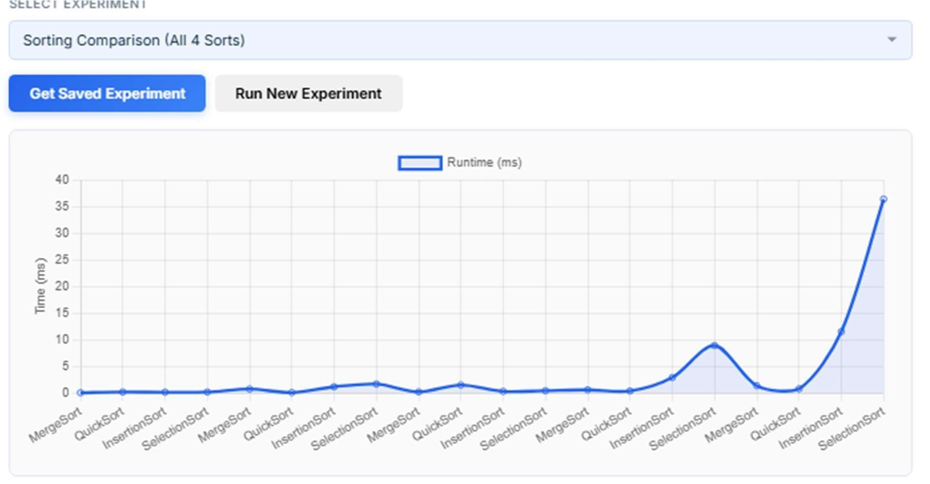
- search-comparison.png — Linear Search's linear curve vs. Binary Search's flat line.
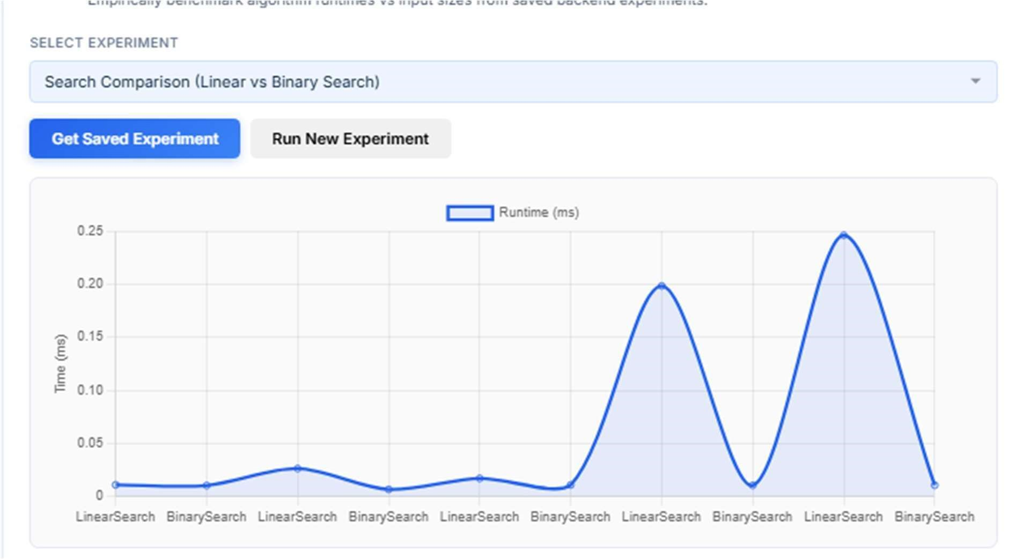
- graph-algorithms.png — BFS, DFS, Dijkstra, Prim, and Kruskal runtime scaling.
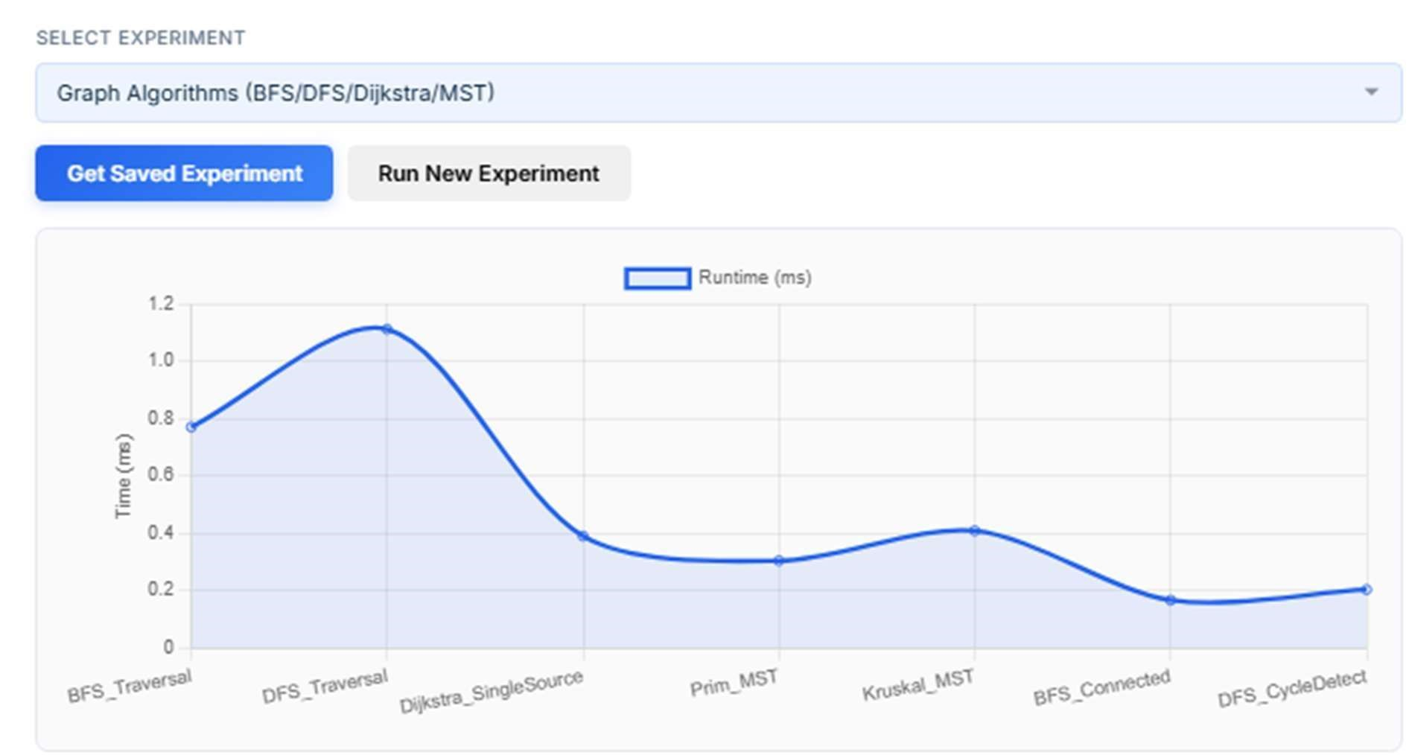
- hash-load-factor.png — load factor vs. collision frequency.
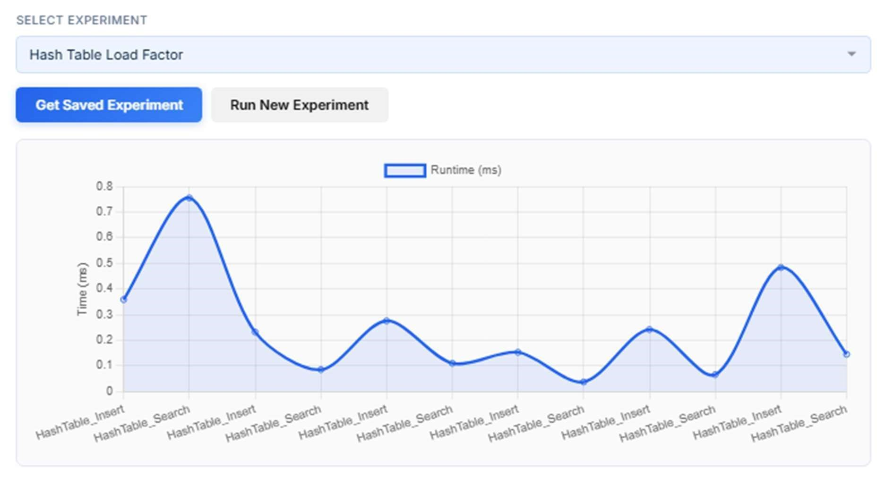

Database Integration & Persistence Evidence

Database Architecture & Seeding
The database layer interacts directly with database/legon_hub.db using JDBC. On startup, DataGenerator and the repository loaders verify that all 6 tables are populated with valid seed data:
- Locations: 58 rows
- Roads: 117 rows
- Service Requests: 300 rows
- Resources: 49 rows
- Algorithm Runs: over 4,000 empirical execution records
- Audit Events: stack-based undo/audit logs
Sample database query — fetching the top 5 pending emergency requests:
SELECT requestId, category, urgency, fineAmountGHS, name AS sourceName FROM service_requests JOIN locations ON service_requests.sourceLocationId = locations.locationId WHERE status = 'Pending' ORDER BY fineAmountGHS DESC LIMIT
5;
- Locations table — rows 1–15, showing names and coordinates.
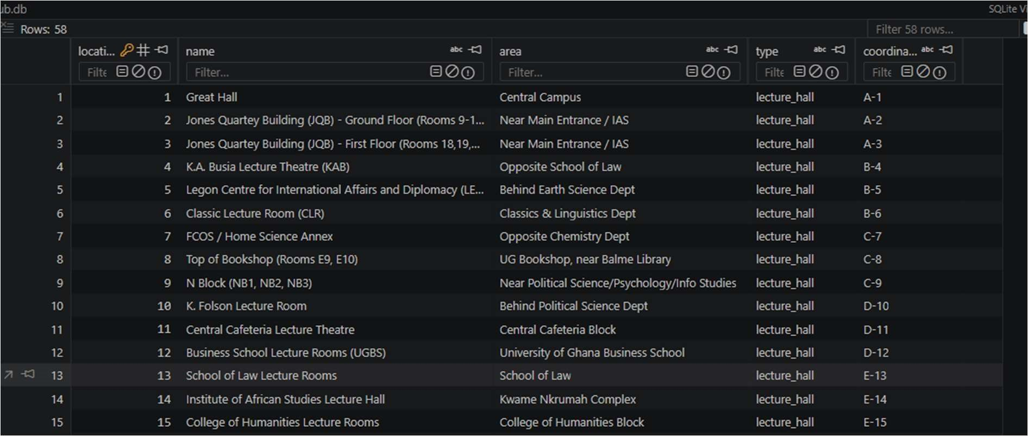
- Roads table — from/to pairs, distances, and condition weights.
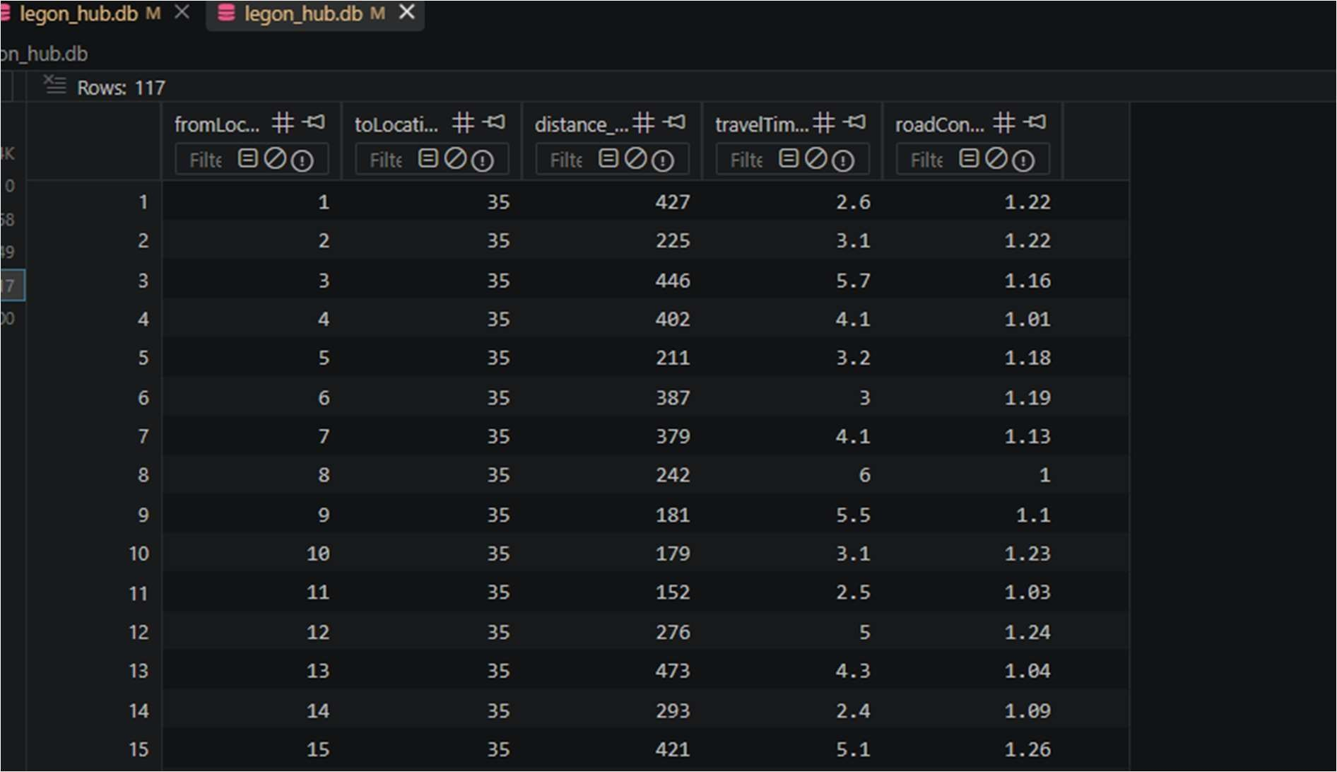
- Service Requests table — active request rows with GHS fine amounts.
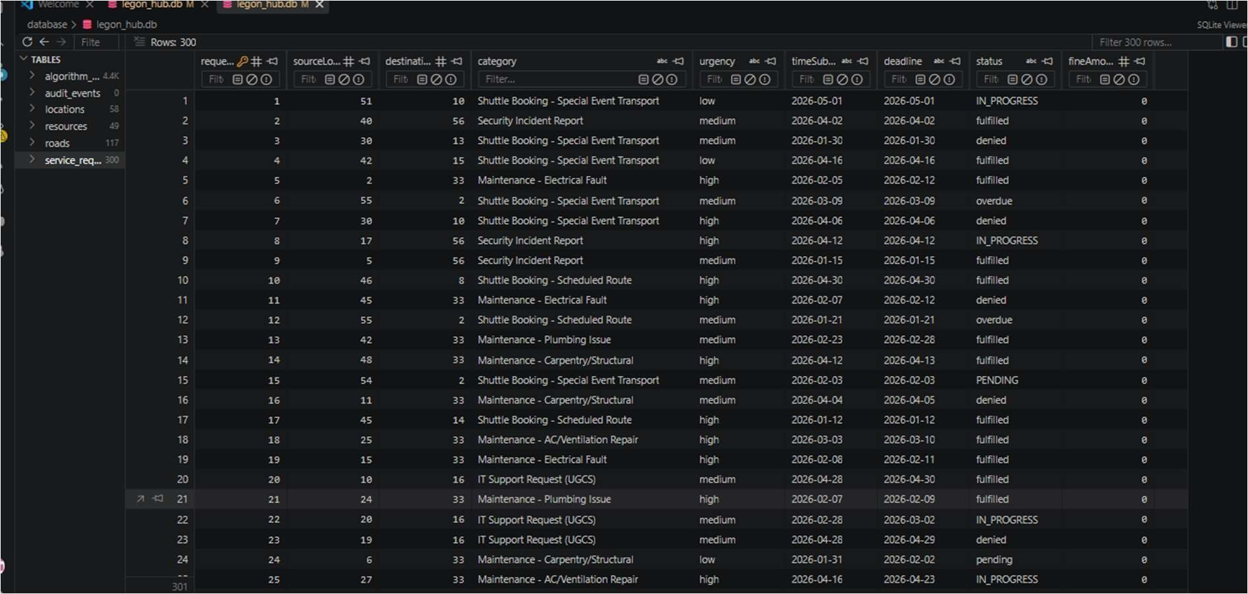
- Resources table
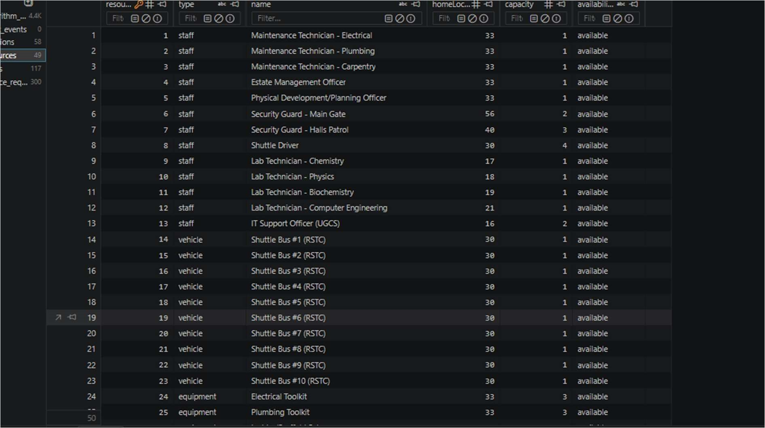
- Algorithm Runs table
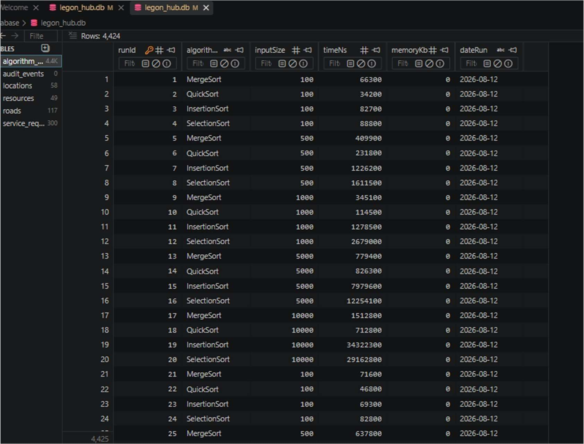
Console Menu Interactive Execution
- The main menu, showing options 1 to 6.
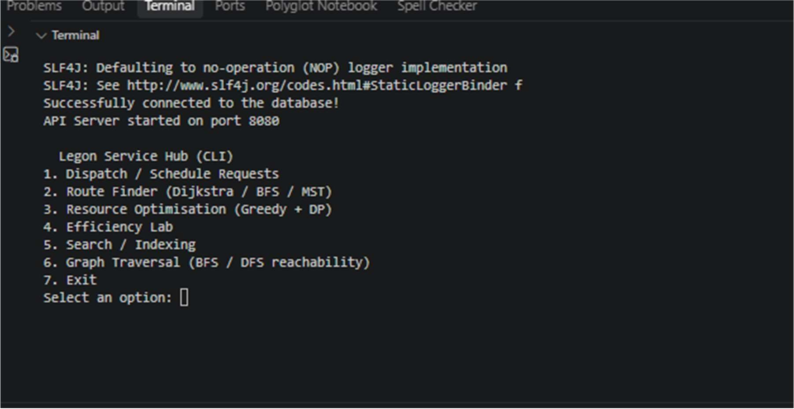

- Option 2 (Route Menu): executing Dijkstra's shortest path from Great Hall (1) to Engineering Annex (58).
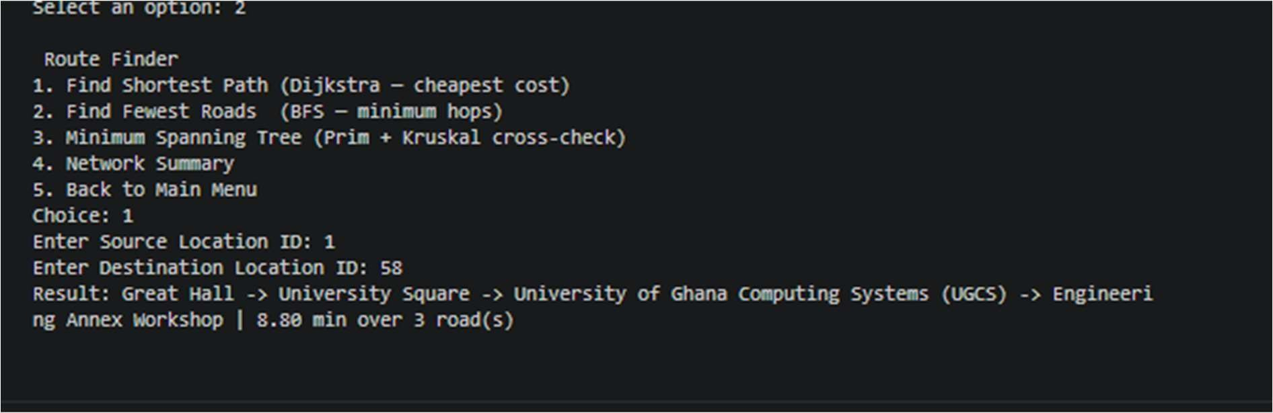
- Option 4 (Optimization Menu): running 0/1 Knapsack optimization and printing the selected request schedule.
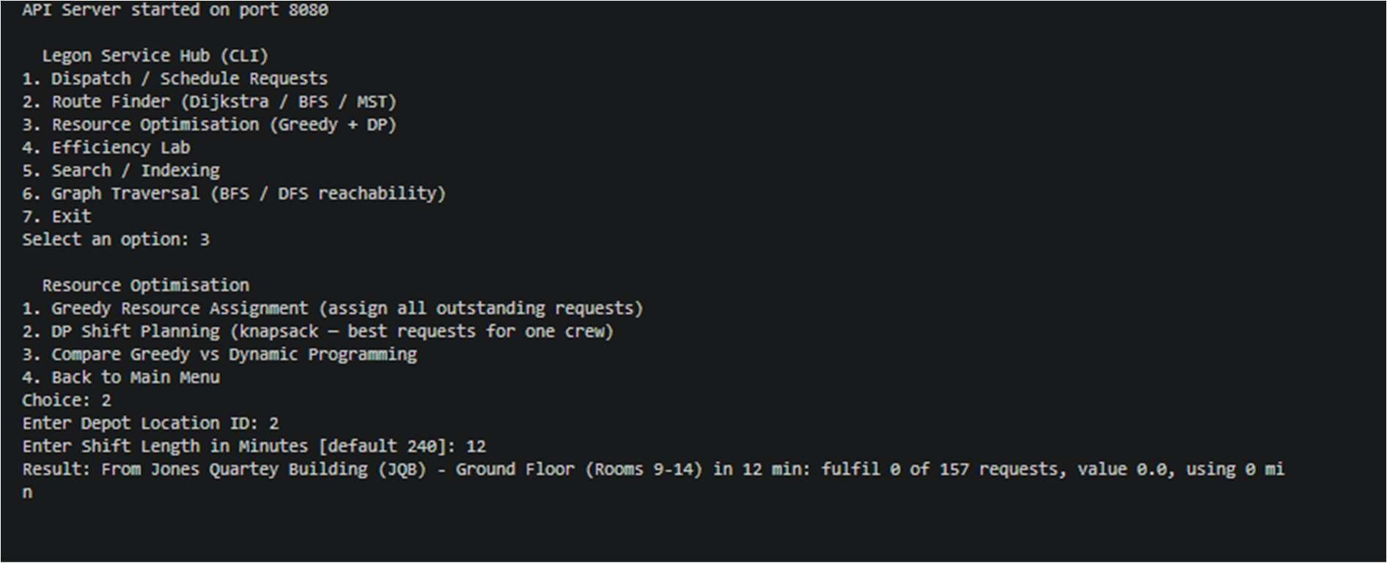

Responsible Algorithm Selection Matrix

Problem Scenario | Recommended Choice | Suboptimal Alternative | Technical Justification
Campus Shortest  Route  (traffic/condition weighted) | Dijkstra's Algorithm with Min-Heap | BFS or Bellman-Ford | BFS ignores edge weights and only minimizes road count; Bellman-Ford wastes O(V·E) time since campus road weights are strictly positive (w > 0).
Zone Reachability / minimum hop count | Breadth-First Search  (BFS) | DFS or Dijkstra | BFS guarantees the fewest road transitions in O(V + E) without heap overhead; DFS can get trapped down long cycles without finding the closest nodes.
Emergency Dispatching (high urgency first) | Binary Min-Heap / PriorityQueue | Unsorted Array or  Sorted Linked List | Min-Heap gives O(log N) enqueue and O(log N) extract-min; an unsorted array costs O(N) per dispatch, and a sorted list costs O(N) per insertion.
Fast Request Lookup by ID | HashTable (separate chaining) | BST or Linear Scan | Hash Table achieves O(1) average lookup; BST costs O(log N) and can
Problem Scenario | Recommended Choice | Suboptimal Alternative | Technical Justification
 |  |  | degrade to O(N) if unbalanced; Linear Scan costs O(N).
Range Queries &  Ordered Campus  Reports | B-Tree or Red-Black Tree | Hash Table | B-Trees and Red-Black Trees maintain sorted in-order traversal in O(N) and range search in O(log N + k); Hash Tables do not maintain order.
Constrained Shift  Schedule  Optimization | 0/1 Knapsack Dynamic  Programming | Greedy valueperminute assigner | Greedy fails to fill capacity and misses the global optimum due to item indivisibility; DP guarantees a 100% optimal schedule.
Campus  Infrastructure  Spanning Tree | Kruskal's Algorithm  (with Disjoint Set) | Prim's Algorithm  (dense matrix) | Kruskal (O(E log E)) outperforms Prim on sparse graphs like road networks, where E ≪ V² (117 ≪ 3,364).

Individual Accountability, Oral Defense Prep & Academic Integrity

Student Index Number Parameter Derivations (AI-Resistance Compliance)
In accordance with Rubric Section 2, the team derived 3 core operational parameters from the sum of all 14 student index numbers:
Team Index Numbers: [22098316, 22056801, 22128981, 22233989, 22069268, 22309657, 22388561, 22304655, 22396017,
22406063, 22375144, 22382281, 22412662, 22299460] Sum of Index Numbers = 311,664,855
19. Parameter 1 — B-Tree Minimum Degree (t):
minDegree = 2 + (Sum mod 4) = 2 + (311,664,855 mod 4) = 2 + 3 = 5
(A production B-Tree node with this degree stores at most 2t − 1 = 9 keys and 2t = 10 child pointers.)
- Parameter 2 — Empirical Benchmark Random Seed:
randomSeed = Sum = 311,664,855 (Ensures
identical, reproducible randomized keys across all benchmark runs.)
- Parameter 3 — Knapsack Priority Urgency Base Value:
urgencyValue = 10.0 + (Sum mod 20) = 10.0 + (311,664,855 mod 20) = 10.0 + 15.0 = 25.0 GHS

Individual Contribution Statements & Pod Work Breakdown
Van-Kpikpi Vanessa Selasi (Index: 22098316 / 22412662) — Lead, Database & Data Architecture:
“I designed and built the database layer for our project. Our local context shifted from the University of Ghana Library System to University Campus Service Hub, an approved context in the brief, after real library data proved hard to source without privacy barriers. I rebuilt the dataset around real UG facilities: lecture halls, laboratories, 14 halls of residence, shuttle stops, and the Physical Development and Municipal Services Directorate (PDMSD).
I designed the SQL schema across six tables with proper keys and constraints, then built four datasets exceeding all minimums: 58 locations, 117 roads, 300 service requests, and 49 resources. A teammate flagged two data quality issues, which I then fixed: 19 duplicate road pairs with inconsistent values, and placeholder location coordinates. I replaced these with synthetic coordinates generated within the campus's real geographic boundary, clearly documented as such rather than presented as verified GPS data.
Since manual CSV imports failed on records with embedded commas, I wrote DataGenerator.java, a Java program that parses and loads the data correctly, making the database reproducible for the whole team. I verified the final database through direct SQL checks on schema, counts, and referential integrity, and set up version control so each teammate builds their own local copy. My teammate and I split the work on M2: I handled the schema and dataset, while they worked on the Java classes that read the data back out for the rest of the system to use.”
Akyea Benjamin Obeng (Index: 22056801) — Database & Data Architecture:
Implemented JDBC connection pooling, prepared statement abstractions, and the repository pattern across all 6 database entities (LocationRepository, RoadRepository, RequestRepository, ResourceRepository, AlgorithmRunRepository, AuditEventRepository), ensuring clean separation between SQL persistence and inmemory algorithm logic.
Isabella Asantewaa (Index: 22128981) — UI & Frontend Dashboard:
Constructed the interactive web dashboard using vanilla HTML/CSS and JavaScript, wired end-to-end REST endpoints in ApiServer.java, and formatted real-time graphical metrics for service dispatch, shortest path routes, and efficiency benchmark visualizers.
Lorretta Opoku Nsiah (Index: 22233989) — Linear Data Structures:
Implemented custom LinkedList (doubly linked with a custom Iterator), Queue, CircularQueue (ring buffer with wrap-around pointers), Deque, Stack, and DynamicArray with automated resizing, backed by dedicated JUnit test suites.
Michael Gorswin Achel (Index: 22069268) — Priority Structures & System Integration:
Engineered the binary Min-Heap (Heap.java) and PriorityQueue, built the system-wide integration layer linking custom data structures to application engines, and enforced zero java.util collections usage across the repository.
Quayson Isaac Awortwe (Index: 22309657) — Priority Structures & Hash Tables:
Implemented HashTable with separate chaining linked buckets, dynamic rehashing on load factor threshold α > 0.75, and custom CustomMap and CustomSet abstractions.
Arhinful Solomon Kwesi (Index: 22388561) — Tree Structures:
Implemented the Binary Search Tree (BST.java) supporting recursive insertion, search, and in-order traversal returning sorted keys for indexing service requests.
Kwabena Awuah Bosompem (Index: 22304655) — Tree Structures:
Implemented self-balancing RedBlackTree with rotations and color flips, and multi-way BTree with proactive node-splitting parameterized by the team-derived minimum degree t = 5.
Gideon Elorm Glago (Index: 22396017) — Graphs & Route Optimization:
Implemented graph representation (Graph.java) using adjacency lists and matrices, Breadth-First Search (BFS.java), Depth-First Search (DFS.java), and Dijkstra's shortest path algorithm (Dijkstra.java).
Duah Ebenezer Ohene Amoako (Index: 22406063) — Graphs & Spanning Trees:
Implemented DisjointSet with union-by-rank and path compression, and Kruskal's and Prim's Minimum Spanning Tree algorithms (Kruskal.java, Prim.java).
Kumah Michael Nhyira & Amenumey Jude Kwame Enam — Searching, Sorting & Testing:
Implemented comparison sort algorithms (MergeSort, QuickSort, InsertionSort, SelectionSort), LinearSearch, BinarySearch, and authored the 192-test JUnit suite.
Bismark Asare & Asante Stephanhy — Technical Reporting & Analysis:
Implemented 0/1 Knapsack Dynamic Programming (KnapsackDP.java), Greedy Assigner (GreedyAssigner.java), EfficiencyLabEngine.java, and compiled the final technical report, trace tables, and performance graphs.

Weekly Development Summary
- Week 1 (Jul 28 – Aug 3, 2026): M1–M2 Foundation & Core Setup
Initialized Git repository and Maven project structure under package `com.campushub`.
Implemented initial linear and priority structures: `Queue`, `Heap`, `PriorityQueue`.
Authored `schema.sql` across 6 database tables and established SQLite JDBC connection.
- Week 2 (Aug 4 – Aug 11, 2026): M2–M4 Data Structure Library & Sorting
Completed `LinkedList` with bidirectional iterator, `Stack`, `CircularQueue`, `Deque`, `BST`, `RedBlackTree`, and `BTree`.
Implemented 4 sorting algorithms (`InsertionSort`, `SelectionSort`, `MergeSort`, `QuickSort`) and search routines.
Vanessa conducted a data-quality audit on `roads.csv`, identifying and fixing 19 duplicate road pairs with conflicting edge weights.
- Week 3 (Aug 11 – Aug 20, 2026): M5–M8 Graph, Optimization & UI Integration
Built the Graph Engine (`Graph`, `DisjointSet`, `BFS`, `DFS`, `Dijkstra`, `Prim`, `Kruskal`) with strict zero `java.util` collection usage.
Implemented 0/1 Knapsack DP optimizer and greedy resource assigner.
Connected backend application engines to interactive `ConsoleMenu.java` CLI and web `ApiServer.java` REST dashboard.
- Week 4 (Aug 20 – Aug 28, 2026): M9–M10 Testing, Benchmarking & Defense Finalization Executed comprehensive JUnit 5 test suite (192 passing unit tests across 26 test classes).
Ran empirical efficiency lab scaling benchmarks (100 \dots 20,000 inputs with 3-run averages) and generated comparative PNG graphs.
Assembled final technical report, 6 trace tables, 3 mathematical proof sketches, and conducted oral defense mock presentations.

AI Assistance Disclosure
Generative AI (Claude) was used during the preparation of this report to assist with structuring and drafting written explanations, checking the report against the project brief for completeness, and improving clarity of technical writing. AI was not used to design or write the core algorithm or data structure implementations in the source code; those were written and tested by the team.
Example prompts used include:
- "Check our project report against this project brief and identify any missing sections or requirements."
- "Help us phrase the correctness proof sketch for our merge sort loop invariant more precisely."

- "Suggest a clearer way to explain our hash table collision handling for the report."
All members of the team are able to explain and, if required, modify the data structure and algorithm implementations described in this report without AI assistance, as demonstrated during the oral defense.

ATTENDANCE
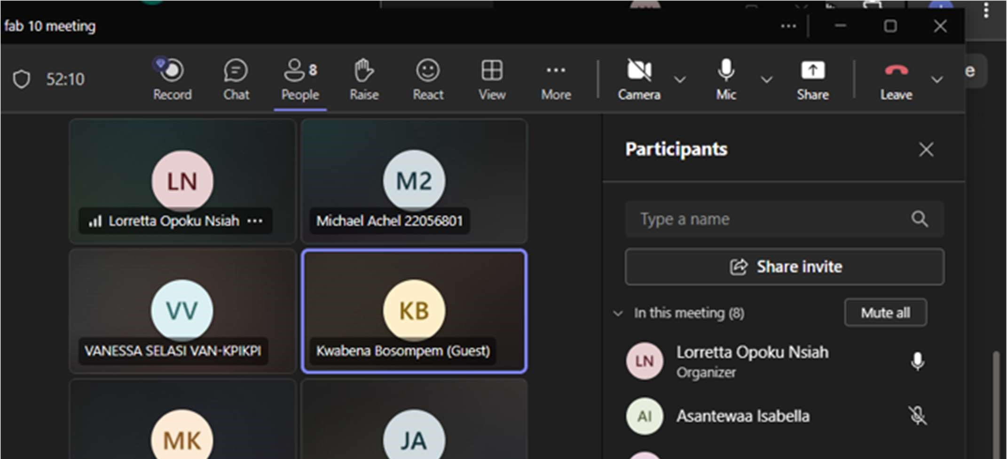


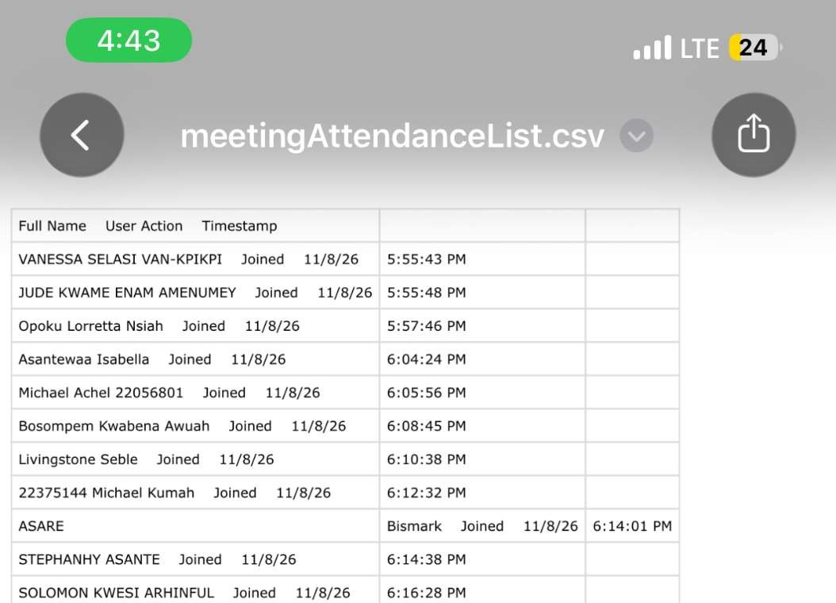

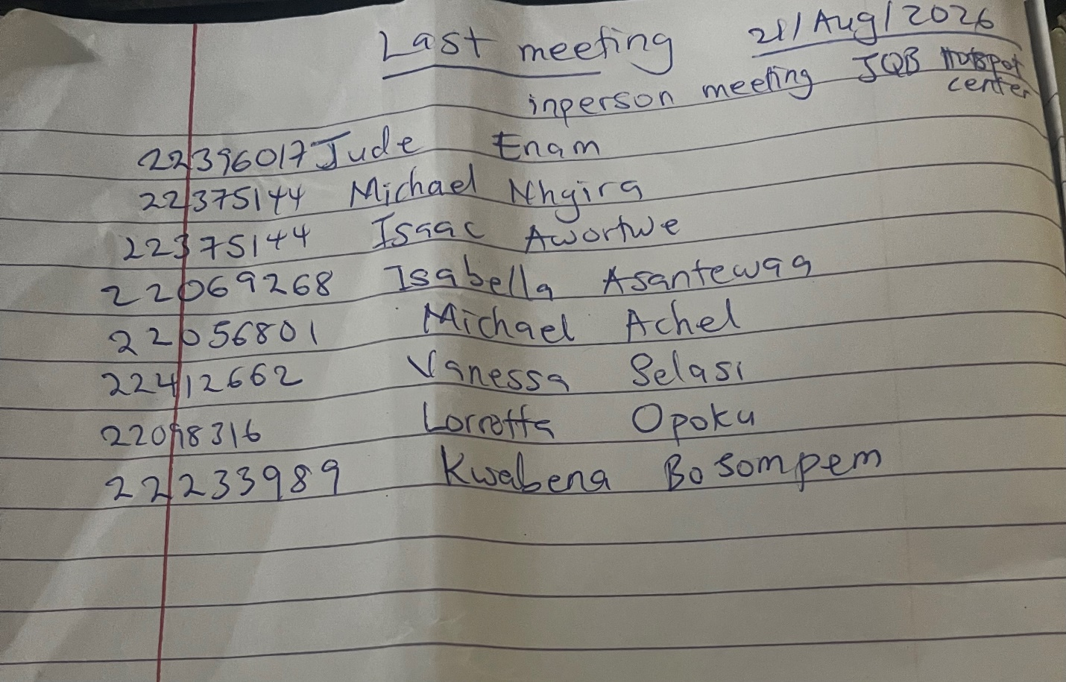

References & Appendices

Academic Textbooks & Algorithmic Foundations
- Cormen, T. H., Leiserson, C. E., Rivest, R. L., & Stein, C. (2022). Introduction to Algorithms (4th ed.). MIT Press.
- Sedgewick, R., & Wayne, K. (2011). Algorithms (4th ed.). Addison-Wesley Professional.
- Goodrich, M. T., Tamassia, R., & Goldwasser, M. H. (2014). Data Structures and Algorithms in Java (6th ed.). Wiley.
- Lewis, J., DePasquale, P., & Chase, J. (2017). Java Foundations: Introduction to Program Design and Data Structures (4th ed.). Pearson.

Primary Dataset & Local Geospatial Sources
- Radio Univers 105.7 FM (2023): “UG: Finding your way around the streets of Legon — A Level 100 Guide.” https://univers.ug.edu.gh/finding-your-way-on-the-streets-of-legon-a-level-100-guide/
- University of Ghana (2022): “VC Commissions Modernised Facilities at Central Cafeteria and JQB Lecture Halls.” https://old1.ug.edu.gh/news/vc-commissions-modernised-facilities-central-cafeteria-and-jqb-lecture-halls
- University of Ghana Interactive Campus Map: https://enkayyy97.github.io/ug-campus-map/
- University of Ghana Academic Affairs: “Handbook for the Bachelor's Degree (ENRECA Ecology Laboratory & Humanities Facilities).” https://www.cui.edu/uploadedfiles/academicprograms/globalprograms/studyabroad/ghana-humanities.pdf
- University of Ghana Academic Affairs Directorate: “Student Accommodation & Residential Halls.” https://www.ug.edu.gh/aad/accomodation
- Moovit Public Transit Index (2024): “How to Get to University of Ghana – Legon in Accra by Bus / Trotro.” https://moovitapp.com/index/en/public_transit-University_Of_Ghana_Legon-Accra-site_80212111-5501
- UG DCS Beat Articles (2014): “Do You Know PDMSD? Physical Development and Municipal Services Directorate.” https://ugdcs2014.wordpress.com/2014/12/05/do-you-know-pdmsd/
- University of Ghana Official News (2016): “University of Ghana Inaugurates Campus Shuttle Service.” https://old1.ug.edu.gh/news/university-ghana-inaugurates-shuttle-service
- Wikipedia Open Geodata: “Akuafo Hall, University of Ghana” (coordinates 5.64944 N, -0.18556 W). https://en.wikipedia.org/wiki/Akuafo_Hall
- Latitude.to Spatial Geodata: “Commonwealth Hall, University of Ghana” (coordinates 5.65060 N, -0.19000 W).

Appendices
- Appendix A: Complete SQL Schema (database/schema.sql).
- Appendix B: Full Graph Algorithm Benchmark Timings (performance/results/graph_algorithm_runs.csv).
- Appendix C: Test Execution Log (192 passing JUnit tests, 0 failures).

